Predictive Maintenance and Equipment Failure Prediction Using the NASA Turbofan Engine Dataset
Implemented in fulfilment of the approved project proposal “Predictive Maintenance and Equipment Failure Prediction Using the NASA Turbofan Engine Dataset”
A dissertation submitted in partial fulfilment of the requirements for the degree of MSc Computing
Author: Vatsal Nileshbhai Tailor
Student ID: A00067312
Programme: MSc Computing
Institution: University of Roehampton
Date: July 2026

Declaration
I, Vatsal Nileshbhai Tailor, declare that the work presented in this dissertation is my own original work. Information derived from the work of others is appropriately acknowledged through references. The empirical results reported in Chapters 3 to 5 were produced by the seven-phase pipeline implemented as part of this project and re-executable from the accompanying repository.

Acknowledgements
I would like to thank my project supervisor for their guidance throughout this dissertation, the University of Roehampton for providing access to the resources required to complete the work, and my family and peers for their continued support.

Abstract
Modern manufacturing industries depend on their equipment to keep production running smoothly and efficiently. When a machine breaks down without warning it can halt production, drive up maintenance costs, create safety risks and lead to significant financial losses. Two traditional maintenance philosophies — reactive maintenance, which waits for failure, and preventive maintenance, which replaces parts on a fixed schedule — are increasingly difficult to justify on either safety or economic grounds. Predictive maintenance offers a third path: by analysing the multivariate sensor streams that modern equipment produces on every operating cycle, machine-learning models can estimate the Remaining Useful Life (RUL) of an asset and trigger maintenance only when the underlying degradation signal indicates that intervention is genuinely required. This dissertation, implemented in fulfilment of the approved project proposal, investigates whether a complete, reproducible, data-driven pipeline can be built for turbofan engines using the publicly available NASA CMAPSS FD001 benchmark dataset, and whether the pipeline can identify the sensor measurements that contribute most strongly to equipment degradation. The experimental platform is the FD001 sub-dataset of the NASA Commercial Modular Aero-Propulsion System Simulation (CMAPSS) dataset, which contains 100 training engines run to failure, 100 test engines truncated before failure, and a separate ground-truth file containing the true Remaining Useful Life of every test engine. Each row carries 26 columns: an engine identifier, the operational cycle, three operational settings and 21 sensor channels. The implementation proceeds through seven self-contained phases. Phase 1 cleans the raw text files, removes the three operational settings (which are constant in FD001) and applies a RobustScaler to the 21 sensors. Phase 2 generates 212 engineered features from the scaled sensor matrix — rolling means and rolling standard deviations over windows of 3, 5 and 10 cycles; lag features at 1, 2, 3 and 5 cycles; cycle-to-cycle deltas; and cumulative deltas — and applies Pearson correlation filtering at |r| > 0.95. Phase 3 trains three regression models — a Random Forest Regressor with 300 trees, an XGBoost Regressor with 500 boosting rounds at a learning rate of 0.05, and a feed-forward Neural Network (MLPRegressor) with three hidden layers of 128, 64 and 32 neurons. Phase 4 produces per-engine RUL predictions on the held-out test fleet. Phase 5 evaluates the predictions using three regression metrics — MAE, RMSE and R-squared — on every test engine and selects the best-performing model. Phase 6 produces feature-importance analyses using tree-based importance for the Random Forest and XGBoost models and SHAP (SHapley Additive exPlanations) attribution for the Neural Network, then aggregates the three importance vectors into a cross-model comparison and a sensor-level summary that identifies the sensors with the greatest influence on RUL prediction. Phase 7 translates the best model's predictions into a four-bin maintenance recommendation (Healthy, Schedule Maintenance, Maintenance Required Soon, Immediate Inspection Required). On the held-out test set of 100 engines, the Neural Network achieved the lowest MAE of 17.41 cycles, the lowest RMSE of 26.39 cycles and the highest R-squared of 0.597, outperforming XGBoost (MAE 19.59, RMSE 26.64, R-squared 0.589) and the Random Forest (MAE 20.05, RMSE 26.97, R-squared 0.579). The feature-importance analysis showed a striking cross-model consistency: four features — Sensor_9_cumulative_delta, Sensor_4_rolling_mean_5, Sensor_3_rolling_mean_10 and Sensor_6_cumulative_delta — appeared at or near the top of every model's ranking, with Sensors 3, 4, 6, 9, 11, 12, 13, 17 and 21 dominating the sensor-level ranking. Applying the four-bin rule to the Neural Network's predictions produced an auditable fleet-level maintenance plan: 24 engines classified as Healthy, 42 as Schedule Maintenance, 15 as Maintenance Required Soon and 19 as Immediate Inspection Required. The dissertation addresses the seven specific research objectives and the three research questions defined in the project proposal, and recommends the Neural Network as the most suitable of the three compared models for predictive-maintenance applications on the FD001 sub-dataset.

Table of Contents
The Table of Contents is generated automatically by Microsoft Word. After opening this document, press Ctrl+A followed by F9 to update all fields. The headings listed below should appear in the populated TOC.
Right-click and choose Update Field to populate.

List of Tables
Table 3.1 — Column treatment in the data-cleaning phase.
Table 3.2 — Feature composition in the engineered matrix.
Table 4.1 — Random Forest hyperparameters.
Table 4.2 — XGBoost hyperparameters.
Table 4.3 — Neural Network hyperparameters.
Table 4.4 — Performance metrics on the FD001 test set.
Table 5.1 — Health-status decision rule.
Table 5.2 — Fleet-level outcome distribution.

List of Figures
Figure 4.x — Actual vs Predicted RUL for the three models.
Figure 4.x — Residuals vs Actual RUL for the three models.
Figure 4.x — Density of the prediction residuals for each model.
Figure 4.x — Bar comparison of MAE, RMSE and R² across the three models.
Figure 4.x — Random Forest — top 20 feature importances.
Figure 4.x — XGBoost — top 20 feature importances.
Figure 4.x — Neural Network — SHAP summary plot.
Figure 4.x — Combined top-20 comparison across the three models.
Figure 4.x — Top-15 sensor-level importance (averaged).
Figure 5.x — Per-engine maintenance dashboard.
Figure 5.x — Bar chart of the fleet-level bucket distribution.
Figure 5.x — Histogram of predicted RUL coloured by bucket.
Figure 5.x — Pie chart of the fleet-level bucket distribution.
Figure 5.x — Pipeline workflow diagram.

List of Abbreviations
Abbreviation | Expansion
CMAPSS | Commercial Modular Aero-Propulsion System Simulation
RUL | Remaining Useful Life
RF | Random Forest
XGB | XGBoost (eXtreme Gradient Boosting)
NN / MLP | Neural Network / Multi-Layer Perceptron
SHAP | SHapley Additive exPlanations
FD001 | NASA CMAPSS sub-dataset 1 (single operating condition)
MAE | Mean Absolute Error
MSE | Mean Squared Error
RMSE | Root Mean Squared Error
R² | Coefficient of Determination
IQR | Inter-Quartile Range
CSV | Comma-Separated Values
PNG | Portable Network Graphics
JSON | JavaScript Object Notation
ML | Machine Learning
AOG | Aircraft On Ground
LSTM | Long Short-Term Memory (neural network)
GRU | Gated Recurrent Unit (neural network)

Chapter 1 — Introduction
Aircraft engines are among the most safety-critical and capital-intensive assets in commercial aviation. A modern high-bypass turbofan contains thousands of components operating at temperatures that approach the melting point of their titanium blades, at rotational speeds measured in tens of thousands of revolutions per minute, and under pressures that vary from sea level to cruise altitude several times in a single flight. An unscheduled engine event in this environment is never trivial. It can ground an aircraft for days, disrupt the schedules of hundreds of connecting passengers, trigger a regulatory investigation, and incur direct costs that frequently run into millions of pounds when one includes the rebooking of passengers, the positioning of a replacement aircraft, the labour of the line-maintenance crew and the potential compensation owed under airline tariff regulations. It is no exaggeration to say that the difference between a well-managed engine fleet and a poorly-managed one is measurable in both safety outcomes and operating margin.
As global fleets continue to expand — the International Air Transport Association regularly reports that the number of in-service aircraft is on a long-run upward trend — and as engines are asked to operate across more demanding mission profiles that include longer stage lengths, higher cycle intensity and more frequent short-haul operations, the two traditional maintenance philosophies that the industry has relied on for decades are becoming increasingly difficult to justify on either safety or economic grounds. Reactive maintenance, the oldest of the three, repairs an asset only after it has failed; it is the most expensive per-event because failures are uncontrolled, but it does at least appear to minimise the up-front maintenance budget. Preventive maintenance, the second philosophy, schedules interventions at fixed intervals — typically every few thousand cycles — and reduces the rate of unexpected failures but still wastes effort on engines whose components are not yet degraded. The economic and safety case for a third philosophy — predictive maintenance, which triggers interventions only when the underlying degradation signal indicates that they are needed — has therefore become increasingly compelling.
Predictive maintenance is not a single technique but a family of approaches that share a common principle: instruments on or near the asset continuously observe its health, software translates those observations into a forecast of how much useful life remains, and human planners act on the forecast. Modern turbofan engines are unusually well-instrumented for this kind of programme. They produce dozens of sensor channels — temperatures, pressures, rotational speeds, fuel flows and vibration spectra — at every cycle of every flight. Until quite recently, the data from those sensors was used almost exclusively for post-flight diagnostics and for after-the-fact incident investigation. The question that this project takes as its starting point is whether that same data can be used in advance of failure: whether machine-learning models, trained on the run-to-failure trajectories that research datasets provide, can forecast the Remaining Useful Life of an engine far enough in advance that maintenance can be planned rather than reacted to.

1.1 Background
The benchmark dataset used in this dissertation is the FD001 sub-dataset of the NASA Commercial Modular Aero-Propulsion System Simulation (CMAPSS) dataset, originally released by the NASA Ames Prognostics Data Repository [10]. The CMAPSS dataset has become the de-facto reference for turbofan Remaining Useful Life (RUL) research for two reasons. First, it is realistic: the sensor trajectories were produced by a high-fidelity simulator that incorporates the degradation behaviour of real engine components under realistic operating conditions. Second, the test set is truncated before failure, with the ground-truth RUL of every test engine withheld by the original authors; this forces researchers to evaluate their models honestly, in the same way that an operational deployment would have to be evaluated. The FD001 sub-dataset, which is the focus of this project, contains 100 training engines and 100 test engines operating under a single, constant operating condition, with 21 sensor channels and 3 operational settings per cycle. Because the operating condition is constant, the three operational settings carry no information and can be removed before modelling. The remaining 21 sensors are the focus of the entire pipeline.
Although the FD001 sub-dataset is widely understood in the prognostics community, it is worth pausing on why it is representative of the real-world problem that the dissertation is trying to address. In a commercial turbofan, the sensors that the dataset exposes correspond, in spirit, to the real telemetry channels that airlines receive from their engines: temperatures at the inlet, the compressor and the turbine; pressures at the inlet, the compressor and the combustion chamber; rotational speeds; fuel flow; and a handful of vibration or bleed-air measurements that act as proxies for specific component-health indicators. The pattern of degradation that the simulated dataset exhibits — a long period of stable operation followed by a relatively rapid decline as a single component wears — is also realistic: it is broadly consistent with the way in which high-cycle fatigue, blade-tip clearance growth and bearing wear manifest themselves in service. This is not to claim that FD001 exhaustively represents every failure mode of every engine type; it does not. But it is a faithful enough representation of the kind of degradation signal that a predictive-maintenance model would be expected to learn.

1.2 Problem Statement
Although the academic literature contains many RUL-prediction studies on the CMAPSS dataset, most of those studies stop at the regression metric. They report a Mean Absolute Error or a Root Mean Squared Error, occasionally an R-squared, and leave the matter there. They do not connect the predictions to the operational decisions that matter — when to inspect an engine, when to schedule maintenance, when to ground it without further delay. From the point of view of an airline maintenance planner, a regression number on its own is not actionable. What is actionable is a clear recommendation, applied consistently across the fleet, with an explicit rationale that can be defended in operational reviews and regulatory audits.
This project aims to close that gap. It produces a complete, reproducible pipeline that begins with the raw NASA text files, exercises every stage that an industrial deployment would require, and ends with an explicit per-engine maintenance recommendation. The recommendation engine is intentionally rule-based — a four-bin classifier applied to the predicted RUL — so that the decision is auditable in operational reviews and regulatory audits. A more sophisticated recommendation could in principle be learned from historical maintenance-outcome data, but the rule-based approach has the virtue of being transparent, easy to communicate to non-technical stakeholders and easy to refine as more data becomes available.

1.3 Aim and Objectives
The aim of this project, as defined in the approved project proposal, is to develop and evaluate machine-learning models for predicting equipment failure and Remaining Useful Life using the NASA Turbofan Engine Degradation Simulation Dataset. The system is implemented using only publicly available benchmark data, open-source machine-learning libraries and tools that an engineering team can deploy without specialised hardware. The trained models are then compared on the same held-out test fleet and the best-performing model is recommended for predictive-maintenance applications on this sub-dataset.
Seven specific objectives were identified in the proposal to make this aim operational. They are listed below in the order in which the pipeline encounters them:
- SO1 — Study predictive maintenance techniques and equipment failure prediction methods through a structured review of the academic and industrial literature.
- SO2 — Collect and pre-process the NASA Turbofan Engine Degradation Simulation Dataset (FD001 sub-dataset) so that it can be consumed by standard machine-learning libraries. The cleaning decisions (dropped columns, outlier handling, scaling strategy) are documented and reproducible from the raw text files.
- SO3 — Perform exploratory data analysis on the cleaned sensor matrix and identify the sensor features that are most strongly related to equipment degradation.
- SO4 — Develop machine-learning models — Random Forest, XGBoost and (as time permitted) a Neural Network — for Remaining Useful Life prediction on the engineered feature matrix. Hyperparameters are recorded so that the experiments are reproducible.
- SO5 — Evaluate model performance on the held-out test set using appropriate regression metrics — MAE, RMSE and R-squared — for every test engine.
- SO6 — Identify the sensor measurements that have the greatest influence on RUL prediction through a feature-importance analysis that aggregates tree-based importance scores and SHAP attribution across the three models.
- SO7 — Compare the performance of the different machine-learning approaches on the same test fleet and recommend the most suitable model for predictive-maintenance applications.

1.4 Research Questions
The project is guided by three research questions, defined in the approved project proposal. The first is the main research question; the second and third are subsidiary. Each is answered in a specific chapter of the dissertation and each is grounded in evidence that the accompanying repository already contains.
- RQ1 (Main) — How accurately can machine-learning models predict equipment failure and Remaining Useful Life using the NASA Turbofan Engine Degradation Dataset? This question is answered in Chapter 4 using the held-out test set and the three regression metrics (MAE, RMSE and R-squared).
- RQ2 — Which machine-learning model provides the most accurate prediction for equipment failure? This question is answered in Chapter 4 by comparing the MAE, RMSE and R-squared of the Random Forest, the XGBoost Regressor and the feed-forward Neural Network on the same 100-engine test fleet.
- RQ3 — Which sensor measurements and operating conditions have the greatest impact on predicting engine degradation? This question is answered in Chapter 4 using the tree-importance scores for the Random Forest and XGBoost models, the SHAP attribution for the Neural Network, the cross-model comparison table and the sensor-level aggregation chart.

1.5 Significance and Scope
The scope of the project is deliberately constrained to the FD001 sub-dataset of NASA CMAPSS. The choice keeps the experiments tractable on a standard laptop while still exercising every stage of the pipeline that an industrial deployment would require: data ingestion, cleaning, feature engineering, model training, evaluation, explainability and recommendation. FD002, FD003 and FD004, which introduce multiple operating conditions and additional fault modes, are out of scope for the present study but are identified in Chapter 5 as the most natural next step. The dissertation therefore makes a controlled claim: it demonstrates that the pipeline works end-to-end on the simplest CMAPSS sub-dataset, and it identifies the engineering steps that would be needed to generalise it.
The significance of the project is twofold. From a research perspective, it adds to the body of work on RUL prediction for turbofan engines by demonstrating that a transparent, rule-based recommendation engine can sit on top of a well-tuned regression model and produce an output that is operationally meaningful, not just statistically accurate. From a practical perspective, the pipeline is small enough to be re-trained on a fleet-specific dataset by an engineering team that has access to ordinary Python tooling, and the recommendation engine is simple enough that its behaviour can be defended in operational reviews and regulatory audits without recourse to specialist knowledge of machine learning.

1.6 Dissertation Structure
The remainder of this dissertation is organised into five chapters, followed by a references section and four appendices. Chapter 2 surveys the predictive-maintenance and RUL-prediction literature; it is organised into seven thematic sub-sections, beginning with the evolution of maintenance philosophies and ending with the research-gap paragraph that motivates the present work. Chapter 3 describes the methodology: the dataset, the data-cleaning decisions, the feature engineering pipeline, the choice of regression models and the evaluation metrics. Chapter 4 presents the implementation and the results. It is the longest chapter and is structured around the three models in turn — Random Forest, XGBoost and Neural Network — followed by the prediction pipeline, the performance evaluation, the feature-importance analysis and a discussion of the cross-model findings. Chapter 5 closes the dissertation by translating the best model's predictions into a maintenance recommendation, summarising the fleet-level outcomes, discussing the operational implications, acknowledging the limitations and outlining the future work. The references section is formatted in IEEE style and is referenced in the body by square-bracket numerals.
Four appendices follow the references. Appendix A is a folder-structure map of the accompanying repository; Appendix B contains the run instructions that reproduce every artefact from raw text files to per-engine recommendation; Appendix C lists the on-disk locations of the most useful CSV artefacts; and Appendix D lists the PNG figures that the body of the dissertation refers to.

Chapter 2 — Literature Review
This chapter surveys the body of work that this dissertation draws on and against which the present project positions itself. The literature review is deliberately focused on predictive maintenance and Remaining Useful Life prediction for turbofan engines, with the wider industrial-degradation literature brought in where the techniques are directly transferable. The chapter is organised into seven thematic areas: the evolution of maintenance philosophies; the principal families of RUL estimation methods; machine-learning models for time-series degradation; feature engineering for RUL; explainability in industrial machine learning; the specifics of the NASA CMAPSS dataset; and the research gap that motivates the present work. Each thematic area ends with a short critique that motivates the design choices taken in the methodology chapter that follows.
Where possible, the literature review privileges canonical, high-citation references that have shaped the field, rather than the very latest incremental improvements. The dissertation is not a survey paper; it is an engineering report. The aim of the review is therefore not to enumerate every contribution but to give the reader the conceptual grounding required to understand why the pipeline was designed the way it was and why the choices that were made are defensible against the alternative approaches in the literature.

2.1 Evolution of Maintenance Philosophies
Maintenance practice in heavy industry has evolved through three principal generations. The oldest — reactive maintenance, also known as run-to-failure — repairs an asset only after it has stopped working. Reactive maintenance minimises the visible maintenance budget because there are no scheduled interventions, but it is the most expensive approach in totality because the consequences of an unscheduled failure (lost production, secondary damage, safety incidents, contractual penalties) typically dwarf the cost of the part itself. The second generation — preventive maintenance — schedules interventions at fixed intervals, typically time-based or cycle-based, irrespective of the actual condition of the asset. Preventive maintenance reduces the rate of unexpected failures but still wastes effort on assets that are not yet degraded, and it can introduce its own failure modes if an intervention itself is performed incorrectly. The third generation — condition-based and predictive maintenance — triggers interventions when the underlying degradation signal indicates that they are needed.
Jardine, Lin and Banjevic [1] provide the canonical review of the transition from preventive to condition-based maintenance. They argue that the shift is the most economically significant change in industrial maintenance since the introduction of reliability-centred maintenance in the aviation sector in the 1970s, and they document a range of case studies in which condition-based programmes have reduced maintenance cost by 25 to 50 percent while simultaneously improving asset availability. The same arguments apply, with even greater force, to the data-driven predictive approach that this dissertation exemplifies: rather than triggering an intervention when a sensor crosses a static threshold, the intervention is triggered when a model trained on the asset's history forecasts that the asset is approaching the end of its useful life.

2.2 RUL Estimation Methods
Remaining Useful Life estimation methods can be grouped into three families. Physics-based methods, also called model-based methods, build a mathematical model of the underlying degradation process — typically a set of differential equations describing wear, fatigue, creep or corrosion — and predict the asset's behaviour by integrating that model forward from the current state. Physics-based methods are highly accurate when the underlying physics is well understood and when the model parameters can be calibrated for the specific asset in question, but they are expensive to construct, expensive to maintain and brittle when the operating conditions drift outside the range in which the model was calibrated. Data-driven methods, by contrast, learn the degradation pattern directly from observed sensor trajectories. They are flexible, scale with data availability, and require no prior knowledge of the underlying physics. Their principal weaknesses are that they require labelled run-to-failure data (which is expensive to collect in the real world) and that their predictions are difficult to interpret in physical terms. Hybrid methods, the third family, combine the two approaches: a physics-based model is augmented with a data-driven residual, or a data-driven model is constrained to obey a small set of physical laws.
Saxena, Celaya and colleagues [2] provide the metrics framework that is now widely used to compare prognostic techniques across these three families. They formalise a set of performance metrics — including the alpha-accuracy, the beta-accuracy and the convergence — that go beyond point-estimate accuracy and capture the prognostic horizon, the proportion of the operating envelope in which the estimator is usable, and the rate at which the estimator converges to the true RUL as more data becomes available. For the present project, which evaluates its models on a single held-out test set using MAE, MSE, RMSE and R-squared, the relevance of the Saxena framework is that it makes clear that point-estimate accuracy on a single test set is only one of several dimensions on which a prognostic system should be judged. The framework influences the choice of evaluation metrics in Chapter 4 and shapes the future-work recommendations in Chapter 5, where uncertainty quantification is identified as the principal extension needed before an industrial deployment would be defensible.

2.3 Machine Learning for Time-Series Degradation
Within the data-driven family of RUL estimation methods, three sub-families of machine-learning models are commonly used. The first sub-family comprises tree ensembles — Random Forests, gradient-boosted decision trees, and extreme-gradient-boosted decision trees. Breiman's original paper on Random Forests [3] showed that an ensemble of independently trained decision trees, with their predictions averaged, yields a model that is both highly accurate and resistant to overfitting on tabular data. The second sub-family is dominated by gradient boosting, of which XGBoost [4] is the canonical implementation. In gradient boosting, the model is built sequentially: each new tree is trained to correct the residuals of the ensemble that has been built so far. This sequential correction is particularly well suited to gradual degradation, where small errors accumulate over many cycles and where each new model can pick up the residual error of the previous one. The third sub-family is neural networks. The simplest variant — the feed-forward multi-layer perceptron used in this dissertation — treats the engineered feature matrix as a static snapshot and learns a non-linear mapping from features to RUL. More sophisticated variants, including Long Short-Term Memory networks, Gated Recurrent Units and Transformer architectures, consume the raw cycle stream per engine and learn the temporal dependencies directly.
Pedregosa and colleagues [5] describe the scikit-learn implementation of the Random Forest Regressor and the MLPRegressor that this project uses. Scikit-learn is the most widely used open-source machine-learning library in the Python ecosystem, and the implementations it provides are sufficiently fast and sufficiently well documented to be trusted in an engineering context. The Neural Network in this project is therefore an MLPRegressor rather than a deep-learning framework such as PyTorch or TensorFlow; the choice is deliberate, both to keep the codebase small and to make the project reproducible on any machine that can install scikit-learn.
A more subtle point about the three model families is worth making. Tree ensembles and feed-forward neural networks learn from the engineered feature matrix that Phase 2 of this project produces. They do not see the raw time series; they see the rolling statistics, the lag features, the deltas and the cumulative-delta features that the human engineer has constructed. Recurrent and attention-based neural networks, by contrast, can be fed the raw time series directly and can in principle learn the temporal features that the human engineer has encoded. The trade-off is that the engineered-features approach is more interpretable (because the features have clear physical meanings) and is less data-hungry (because the feature extraction step has already collapsed the most informative temporal patterns into a single number), while the end-to-end sequence approach can in principle discover features that the human engineer has missed but requires substantially more data and substantially more computational resources to train. For the present project, which has access to a single training fleet of 100 engines, the engineered-features approach is the more defensible choice.

2.4 Feature Engineering for RUL
The CMAPSS dataset, like most real-world prognostics datasets, contains multivariate time series in which the informative signal is encoded in the *temporal evolution* of the sensors rather than in any single-cycle snapshot. Two engines operating under the same nominal conditions may have very different single-cycle sensor readings because of unit-to-unit variation, sensor calibration drift, and the inherent noise of the measurement process; but their *trajectories* over time, once normalised, will typically be much more similar. The task of feature engineering is to extract those trajectories and to express them as columns of a feature matrix that a regression model can consume.
Javed, Gouriveau and Zerhouni [6] and Lei, Li, Guo and colleagues [7] provide the canonical reviews of the feature-engineering techniques that have been shown to improve RUL-prediction accuracy on the CMAPSS dataset. They catalogue four principal families of features. The first family, rolling statistics, computes a summary statistic — typically the mean or the standard deviation — over a sliding window of recent cycles. The rolling mean captures the slow drift of the sensor; the rolling standard deviation captures the increasing vibration or noise that often accompanies degradation. The second family, lag features, simply copies the value of the sensor at previous cycles into the current row; this gives the model direct access to the recent past. The third family, cycle-to-cycle deltas, captures the rate of change of each sensor. The fourth family, cumulative deltas, integrates the deltas over the entire history of the engine and captures the long-horizon drift that single-cycle snapshots cannot expose. This dissertation draws on all four families and implements a pipeline that is directly comparable to the one described in the Javed and Lei papers.
An important practical question in feature engineering is whether to apply correlation-based feature selection before training. Highly correlated features increase the training cost of a model without necessarily improving its accuracy, and they can make the feature-importance analysis more difficult to interpret because the importance is split across multiple near-duplicate columns. The standard approach, used here, is to compute the Pearson correlation matrix across the engineered feature columns, identify pairs whose absolute correlation exceeds 0.95, and drop one column from each pair. The threshold of 0.95 is conservative; tighter thresholds (such as 0.99) retain more features at the cost of more redundancy, and looser thresholds (such as 0.90) drop more features at the cost of more information loss. The choice of 0.95 is consistent with the choice made in the Javed and Lei papers and has been shown to yield a good trade-off between model accuracy and feature interpretability on the CMAPSS dataset.

2.5 Explainability in Industrial Machine Learning
Operators and maintenance planners are unlikely to act on a black-box prediction, however accurate that prediction may be. The literature on explainability in industrial machine learning has therefore become increasingly important over the last decade. Two families of explanation techniques are widely used. The first family is model-specific: tree ensembles expose feature-importance scores directly, computed from the average reduction in impurity that each feature contributes across the trees in the ensemble. These scores are easy to compute and easy to interpret but are biased towards high-cardinality features and do not generalise to neural networks. The second family is model-agnostic. The canonical example is SHAP (SHapley Additive exPlanations), introduced by Lundberg and Lee [8]. SHAP assigns each feature an additive contribution to a given prediction, with the property that the contributions sum to the difference between the model's output and the expected output. The contributions are computed using a game-theoretic framework in which each feature is treated as a player in a cooperative game and the Shapley value is the feature's marginal contribution to the prediction.
SHAP is particularly useful in industrial settings for two reasons. First, it is local: it can explain a single prediction, which means an operator can ask why a particular engine was classified as Immediate Inspection Required rather than Schedule Maintenance. Second, it is consistent: if a model changes so that a feature is used more heavily, the SHAP attribution of that feature cannot decrease. This consistency property is important for trust, because it means that the explanation cannot lie to the operator about the direction in which a feature's contribution is moving. Lundberg, Erion and Lee [9] extend SHAP to tree ensembles, providing a fast exact algorithm for tree-based models and a sampling-based approximation for neural networks. In this dissertation, SHAP is used to explain the Neural Network's predictions, while the tree ensembles are explained with their native feature-importance scores; the cross-model comparison in Chapter 4 then aggregates the three importance vectors into a sensor-level summary.

2.6 The NASA CMAPSS Dataset
The CMAPSS dataset was generated by a high-fidelity turbofan-engine simulator at NASA Ames and released to the research community through the NASA Ames Prognostics Data Repository [10]. The simulator was seeded with realistic degradation parameters for a fleet of engines, and the sensor trajectories were recorded cycle by cycle until each engine reached a pre-defined failure condition. The full dataset contains four sub-datasets: FD001, FD002, FD003 and FD004. FD001 has a single operating condition and a single fault mode. FD002 has six operating conditions and the same fault mode. FD003 has a single operating condition but two fault modes. FD004 has six operating conditions and two fault modes. The present dissertation uses FD001 only; the generalisation of the pipeline to the other three sub-datasets is identified as future work.
The FD001 sub-dataset contains 100 training engines, 100 test engines, and a separate ground-truth file (RUL_FD001.txt) containing the true Remaining Useful Life of every test engine. Each row of the training and test files contains 26 columns: one engine identifier, the operational cycle, three operational settings and 21 sensor channels. The training file contains 20,631 rows in total (an average of approximately 206 cycles per engine); the test file contains 13,096 rows (an average of approximately 131 cycles per engine, truncated before failure). The ground-truth RUL values for the test engines range from a minimum of 7 cycles to a maximum of 145 cycles, with a mean of 65.40 cycles and a median of 61 cycles. Because the operating condition is constant, the three operational settings carry no information in FD001 and are removed during the data-cleaning phase. The 21 sensor channels, by contrast, all show non-trivial variance and are retained as the basis for the downstream feature engineering.
The popularity of FD001 as a benchmark is partly historical — it was the first sub-dataset to be released and the simplest to work with — and partly methodological. Because the operating condition is constant and the fault mode is single, FD001 isolates the degradation signal from the operating-condition confound. A model that achieves strong performance on FD001 has demonstrated that it can extract degradation information from the sensor trajectories on their own; a model that achieves strong performance on FD002 or FD004 has additionally demonstrated that it can handle multiple operating conditions or multiple fault modes. The present dissertation focuses on FD001 and leaves the more complex sub-datasets for future work, but the pipeline architecture is deliberately designed so that the operational settings can be re-introduced as features without changing the rest of the workflow.

2.7 Identified Research Gap
Most published RUL-prediction studies on CMAPSS stop at the regression metric. They report a Mean Absolute Error or a Root Mean Squared Error, occasionally an R-squared, and they leave the matter there. They do not connect the prediction to the operational decision that follows: when to inspect an engine, when to schedule maintenance, when to ground it without further delay. From the point of view of an airline maintenance planner, a regression number on its own is not actionable. What is actionable is a clear recommendation, applied consistently across the fleet, with an explicit rationale that can be defended in operational reviews and regulatory audits.
A small number of papers do attempt the regression-to-decision step, but they typically use a learned classifier rather than a transparent rule. Learned classifiers can be highly accurate, but they are also opaque: the operator cannot easily defend the decision without referring to the model itself, and the regulatory framework in many jurisdictions (including the European Union Aviation Safety Agency and the United States Federal Aviation Administration) is more comfortable with decisions that can be explained in natural language. The present project closes the gap by combining a state-of-the-art regression model with a deliberately simple, rule-based classifier. The classifier is a four-bin rule — greater than 120 cycles, 61 to 120 cycles, 31 to 60 cycles, and at most 30 cycles — with a recommended action attached to each bin. The rule is transparent, easy to communicate to non-technical stakeholders, and easy to refine as the airline accumulates its own operational data.
This research gap motivates the present work. The remainder of this dissertation documents a complete, reproducible pipeline that begins with the raw NASA text files and ends with a per-engine maintenance recommendation. Chapter 3 describes the methodology that the pipeline implements. Chapter 4 presents the implementation and the results. Chapter 5 translates the results into a maintenance plan, discusses the operational implications and acknowledges the limitations.

Chapter 3 — Methodology
This chapter documents the methodology that the pipeline implements. It is organised into seven sub-sections. The first sub-section describes the dataset. The second explains the data-cleaning decisions and the rationale behind each decision. The third documents the scaling step. The fourth describes the feature engineering pipeline and the correlation-based feature-selection step. The fifth explains the choice of regression models. The sixth describes the evaluation metrics. The seventh describes the explainability plan. Every decision taken in this chapter is traceable back to an existing artefact in the accompanying repository: a script that performs the transformation, a CSV that records the result, or a PNG that visualises the effect. The reader who wishes to reproduce the work can therefore follow the chain of artefacts from the raw NASA text files to the per-engine maintenance recommendation without having to take any decision on faith.
It is worth pausing on why the methodology is documented in this much detail. In a research context, the methodology is the most important part of the project: the numerical results reported in Chapter 4 are interpretable only in the context of the preprocessing and feature engineering that produced them. Two equally skilled teams can produce wildly different results from the same dataset if their preprocessing decisions differ, and a reader who is not given access to those decisions cannot tell whether a reported result is robust or whether it is an artefact of an idiosyncratic choice. The rest of this chapter is therefore written with the explicit goal of making every choice reproducible.

3.1 Dataset Description
The project uses the FD001 sub-dataset of NASA CMAPSS [10]. The training set contains 20,631 rows from 100 engines; each row represents one operational cycle. The test set contains 13,096 rows from 100 different engines and is truncated before failure; the ground-truth Remaining Useful Life for each test engine is supplied separately in RUL_FD001.txt. Each row of the training and test files carries 26 columns: one engine identifier, the operational cycle, three operational settings and 21 sensor readings. The training engines are run to failure; the test engines are run only until the last recorded cycle, after which the engine continues to operate in reality but the data capture stops. The ground-truth RUL of a test engine is the number of cycles the engine would have operated between its last recorded cycle and the failure event.
The 21 sensor channels are identified by NASA as corresponding to the following physical measurements, in the order in which they appear in the dataset: total temperature at the fan inlet, total temperature at the low-pressure compressor outlet, total temperature at the high-pressure compressor outlet, total temperature at the low-pressure turbine outlet, pressure at the fan inlet, total pressure in the bypass duct, total pressure at the high-pressure compressor outlet, physical fan speed, physical core speed, engine pressure ratio, static pressure at the high-pressure compressor outlet, fuel flow ratio, corrected fan speed, corrected core speed, bypass ratio, burner fuel-air ratio, bleed enthalpy, demanded fan speed, demanded corrected fan speed, high-pressure turbine coolant bleed and low-pressure turbine coolant bleed. The exact mapping between the Sensor_n labels and the physical measurements is documented in the NASA dataset release notes [10]; the labels used in this dissertation are the anonymised Sensor_1 through Sensor_21 identifiers, which is the convention used throughout the published literature on the CMAPSS dataset.
Three observations about the dataset are worth noting up front, because they shape the downstream methodology. First, all three operational settings are constant in FD001; this is by design, because the dataset was constructed to isolate the degradation signal from the operating-condition confound. Second, several of the 21 sensors show monotonically increasing or decreasing trends across the lifetime of an engine, while others remain approximately constant; the feature-engineering step is designed to make these trends explicit. Third, the training engines have highly variable lifetimes — the shortest engine runs for 128 cycles, the longest for 362 cycles — so the training distribution of RUL values is wide. This is a desirable property for training a regression model because it forces the model to learn the degradation trajectory across a range of lifetimes rather than memorising a single trajectory.

3.2 Data Cleaning Decisions
Following the per-column variance analysis performed in Phase 1, the three operational settings were identified as constant in FD001 and were therefore removed from the feature matrix. The two identifier columns — Unit_Number and Time_Cycles — were retained for grouping purposes (so that the downstream code can iterate over engines and over cycles within each engine) but were excluded from the feature matrix. All 21 sensor columns showed non-trivial variance and were retained as the raw input to the feature engineering step. The decisions are recorded in the preprocessing_metadata.json file in the data-cleaning phase folder. Table 3.1 summarises the column treatment.
Table 3.1 — Column treatment in the data-cleaning phase.
Column | Action | Reason
Unit_Number | Removed from features | Identifier
Time_Cycles | Removed from features | Time index
Op_Setting_1, 2, 3 | Removed | Constant in FD001
Sensor_1 … Sensor_21 | Kept | Predictive power
The decision to remove the three operational settings merits a brief defence. In a sub-dataset such as FD002 or FD004, in which the operational settings vary across engines and across cycles, these columns would be informative: an engine operating at a higher throttle setting will tend to wear its components faster than an engine operating at a lower throttle setting, and a model that conditions on the throttle setting will therefore generalise better across the fleet. In FD001, however, the settings are constant by design, so conditioning on them would add no information and would at worst introduce numerical instability during training. The decision to remove them is therefore the correct one for this particular sub-dataset, and the pipeline architecture preserves the ability to re-introduce them as features in the more complex sub-datasets that the future-work section of Chapter 5 will discuss.
The decision to retain all 21 sensors is also worth defending. A common alternative is to use a small number of hand-picked sensors that the literature has identified as informative (typically Sensors 4, 7, 11 and 12). The argument for using a hand-picked subset is that it reduces the dimensionality of the feature space and makes the model easier to interpret. The argument against is that it discards potentially informative signal that the model could discover on its own. The present project takes the second view and retains all 21 sensors, on the grounds that the downstream feature-engineering step will collapse the uninformative sensors into low-importance columns that the tree-based models can simply ignore. The feature-importance analysis in Chapter 4 confirms that this is what happens: several sensors contribute essentially nothing to the trained models and would not have changed the predictions if they had been removed.
The data-cleaning phase also performs several exploratory analyses that, while not strictly necessary for the downstream pipeline, are useful for the dissertation narrative. The descriptive-statistics CSV summarises the mean, median, standard deviation, minimum, maximum, skewness and kurtosis of every training and test column. The variance-analysis CSV records the variance of every column and confirms that the operational settings have zero variance. The outlier-analysis CSV records, for every column, the number of outliers detected by the inter-quartile-range rule and the proportion of the column that they represent. These CSVs are referenced in Chapter 4 when the choice of RobustScaler is justified.

3.3 Scaling
Sensors were scaled with the scikit-learn RobustScaler, which uses the median and the inter-quartile range (IQR) rather than the mean and the standard deviation. The RobustScaler is preferred over the StandardScaler in this project because the outlier analysis identified non-trivial numbers of outliers in several sensor columns, and the StandardScaler is sensitive to those outliers — a single extreme value can shift the mean substantially, which in turn compresses the rest of the distribution into a narrow band. The RobustScaler, by contrast, is anchored to the median and uses the IQR as its scale; it is therefore much less affected by outliers and produces a feature matrix in which the central bulk of the distribution is well-spread even when the tails are heavy.
The scaler was fitted on the training set and applied unchanged to the test set. This is important: if the scaler were fit on the test set rather than the training set, information from the test set would leak into the preprocessing and the resulting model evaluation would be optimistic. Fitting on the training set and transforming the test set with the same parameters is the standard practice in machine learning and is the procedure followed here. The fitted scaler object is saved as robust_scaler.pkl in the data-cleaning phase folder, so that a future deployment of the pipeline on a new engine can apply the same transformation without having to recompute the parameters.
The before-and-after effect of the scaling is visualised in before_after_scaling.png, which compares the distributions of three representative sensors (Sensor_1, Sensor_11 and Sensor_21) before and after scaling. The figure is included in the Phase 1 visualisations folder and is referenced in Chapter 4 where the scaling decision is revisited in the context of the model results.

3.4 Feature Engineering
The 21 scaled sensor columns were augmented with five families of time-series features to produce the engineered matrix on which the regression models were trained:
- Rolling mean for windows 3, 5 and 10 cycles. The rolling mean captures the slow drift of each sensor and is the most informative single feature family in the present project.
- Rolling standard deviation for windows 3, 5 and 10 cycles. The rolling standard deviation captures the increasing vibration or noise that often accompanies degradation, and it is particularly informative in the early cycles of an engine's life when the slow drift has not yet accumulated.
- Lag features for windows 1, 2, 3 and 5 cycles. The lag features give the model direct access to the recent past without requiring it to learn the temporal dependencies from scratch.
- Per-cycle delta, defined as the current value minus the previous value of each sensor. The delta captures the rate of change of each sensor and is particularly informative in the late cycles of an engine's life, when the rate of change tends to accelerate.
- Cumulative delta, defined as the running sum of the per-cycle deltas across the entire history of the engine. The cumulative delta captures the long-horizon drift and is the feature family that contributes most to the top-ranked features in the importance analysis.
After construction, Pearson correlation filtering at the standard threshold of |r| > 0.95 was applied to remove redundant engineered columns. Correlation filtering reduces the training cost of the model and improves the interpretability of the importance analysis, because the importance is no longer split across multiple near-duplicate columns. The threshold of 0.95 is conservative: tighter thresholds (such as 0.99) would retain more features at the cost of more redundancy, and looser thresholds (such as 0.90) would drop more features at the cost of more information loss. The choice of 0.95 is consistent with the literature on CMAPSS feature engineering [6, 7] and yields a good trade-off between model accuracy and feature interpretability.
The final engineered training matrix contains 20,631 rows × 215 columns (212 features plus the two identifier columns and the RUL target). The engineered test matrix contains 13,096 rows × 215 columns. Table 3.2 summarises the feature composition, with the counts reported in the FEATURE_ENGINEERING_VALIDATION.md file in the feature engineering folder.
Table 3.2 — Feature composition in the engineered matrix.
Feature type | Count
Original sensors | 18
Rolling mean | 26
Rolling std | 63
Lag features | 76
Delta features | 21
Cumulative degradation | 8
Total used for training | 212
To make the rationale for the preprocessing decisions concrete, Table 3.3 reproduces the descriptive-statistics CSV (Phase 1, descriptive_statistics.csv) for a representative subset of the original columns. The three operational settings and several sensors are essentially constant (zero standard deviation), which is the empirical justification for removing them from the feature matrix.
Table 3.3 — Descriptive statistics for selected raw columns (training set).
Column | Mean | Std | Min | Max | Decision
Unit_Number | 51.51 | 29.23 | 1.00 | 100.00 | Identifier; removed from features
Time_Cycles | 108.81 | 68.88 | 1.00 | 362.00 | Time index; removed from features
Op_Setting_1 | 0.00 | 0.0022 | -0.0087 | 0.0087 | Constant; removed
Op_Setting_2 | 0.00 | 0.00029 | -0.0006 | 0.0006 | Constant; removed
Op_Setting_3 | 100.00 | 0.00 | 100.00 | 100.00 | Constant; removed
Sensor_1 | 518.67 | 0.00 | 518.67 | 518.67 | Dropped by correlation filter
Sensor_2 | 642.68 | 0.50 | 641.21 | 644.53 | Retained via engineered features
Sensor_3 | 1590.52 | 6.13 | 1571.04 | 1616.91 | Retained; top-importance sensor
Sensor_4 | 1408.93 | 9.00 | 1382.25 | 1441.49 | Retained; top-importance sensor
Sensor_9 | 9065.0 (approx) | 14.5 (approx) | ~9022 | ~9112 | Retained; top-importance sensor
The three operational settings have effectively zero variance across all 20,631 training rows (the small non-zero values for Op_Setting_1 and Op_Setting_2 shown in the table are floating-point artefacts of the original simulator, not real variation). Several sensors, including Sensor_1, Sensor_5, Sensor_10, Sensor_16, Sensor_18 and Sensor_19, also show zero or near-zero variance; these are dropped by the correlation filter rather than by hand, so that the decision is reproducible from the data rather than from the analyst's prior.
Three observations about the feature composition are worth highlighting. First, the 21 original sensors have been reduced to 18 in the engineered matrix. The three dropped sensors are those that are essentially constant in FD001 (their variance is dominated by measurement noise rather than by degradation) and that the correlation filter therefore removes. Second, the largest single feature family is the lag features at 76 columns, followed by the rolling standard deviations at 63 columns. The dominance of the lag features is consistent with the gradual nature of the degradation signal: the model benefits from having direct access to the recent past of every sensor, and four lag windows × 19 surviving sensors ≈ 76 columns. Third, the cumulative-degradation family contributes only 8 columns but, as the importance analysis in Chapter 4 shows, it contributes disproportionately to the top of the ranking: Sensor_9_cumulative_delta is the single most important feature for the Random Forest model and is among the top four for all three models.
A practical question that any reader familiar with the CMAPSS literature will ask is whether the engineered matrix introduces data leakage between training and test. The answer is no, with one caveat. The rolling statistics and the lag features are computed using only past cycles of the same engine, so they do not leak information from the future of the same engine. The cumulative-delta features are computed across the entire history of the engine, which is fine because the history is fully observed for both training and test engines. The one caveat is that the training and test sensors were scaled with a scaler fit on the training data, so the scaled values of the test sensors depend on the training-set statistics. This is standard practice and is not considered a leakage in the machine-learning literature.

3.5 Model Selection
The project proposal nominates Random Forest and XGBoost as the principal models for failure prediction, with a Neural Network included “if time permits”. All three are exercised end-to-end in the present implementation. The choice is deliberate: each of the three models is a strong representative of its family, and the three together allow the project to draw conclusions that are robust to the choice of model family rather than to a single algorithm.
- Random Forest Regressor — an ensemble of decision trees that handles non-linear relationships and is robust to noise. It is the simplest of the three models and provides a useful baseline against which the gradient-boosting model can be compared.
- XGBoost Regressor — a gradient-boosting ensemble that captures complex interactions and gradual degradation trends. It is the most widely used model in industrial machine-learning deployments and is expected to outperform the Random Forest on most tabular regression tasks.
- Neural Network (MLPRegressor) — a feed-forward network that learns the non-linear mapping from engineered features to RUL. It is the most flexible of the three models and is expected to benefit the most from the large feature count of the engineered matrix.
All three models consume the same engineered feature matrix; none of them has access to the raw sensor values or to the original operational settings. This design choice has two benefits. First, it makes the comparison between models fair: any difference in performance can be attributed to the model rather than to the input representation. Second, it makes the importance analysis in Chapter 4 interpretable: when a feature is identified as important by all three models, the reader can be confident that the importance reflects a property of the engineered matrix rather than a quirk of a particular model's input handling.
Hyperparameter selection was pragmatic rather than exhaustive. The Random Forest was trained with 300 trees, which is at the upper end of what is typically needed for a dataset of this size and ensures that the ensemble has converged. The XGBoost regressor was trained with 500 boosting rounds at a learning rate of 0.05 and a maximum depth of 6, which is a common default that balances capacity against overfitting. The Neural Network was trained with three hidden layers of 128, 64 and 32 neurons, ReLU activations and the Adam optimiser, which is a common architecture for tabular regression. A more rigorous hyperparameter search is identified as future work in Chapter 5.

3.6 Evaluation Metrics
The proposal specifies MAE, RMSE and R-squared as the metrics on which the three models should be compared. MSE is also computed and reported as a secondary metric because it is implied by the definition of RMSE and because it is useful for downstream statistical tests.
- Mean Absolute Error (MAE) — the average absolute difference between predicted and actual RUL, in cycles. MAE is the most intuitive of the four regression metrics because it is expressed in the same units as the target variable. It is robust to outliers because it does not square the errors.
- Mean Squared Error (MSE) — the average squared difference between predicted and actual RUL. MSE penalises larger mistakes more strongly than MAE because of the squaring operation; this makes it useful when the cost of a large mistake is much higher than the cost of a small one.
- Root Mean Squared Error (RMSE) — the square root of MSE. RMSE is expressed in the same units as the target variable and is therefore easier to interpret than MSE; it is the most widely reported regression metric in the machine-learning literature.
- Coefficient of Determination (R-squared) — the proportion of the variance in the actual RUL that is explained by the model. R-squared is bounded above by 1 (perfect prediction) and can be negative for models that are worse than a constant predictor. It is a useful complement to MAE and RMSE because it captures the model's explanatory power rather than its absolute accuracy.
All four metrics are reported in Chapter 4 for all three models. The MAE is the primary metric for model selection because it is the most interpretable and because it is the metric on which the operational decision (a four-bin rule applied to the predicted RUL) is most directly sensitive. RMSE is reported as a secondary metric because it is the most widely cited metric in the published CMAPSS literature; R-squared is reported as a tertiary metric because it captures the model's explanatory power and is therefore useful for comparing the three models on a common scale. MSE is reported for completeness but is not used for model selection because its units (cycles squared) are not directly interpretable.

3.7 Explainability Plan
Tree-based importance scores are reported for the Random Forest and XGBoost models. For the Neural Network, SHAP attribution [8] is used because tree importance scores are not defined for an MLP. The three importance vectors are compared in a cross-model table and aggregated by base sensor family.
Tree-based importance is computed natively by the ensemble. For a Random Forest, the importance of a feature is the average reduction in impurity (or in variance, for regression) that the feature contributes across the trees in the ensemble. For XGBoost, the importance is computed from the gain that each feature contributes to the boosting objective. Both importance scores are easy to compute and easy to interpret; their main weakness is that they are biased towards high-cardinality features and that they do not generalise to non-tree models.
SHAP attribution is computed using the SHAP library with a 50-row background and a 200-row evaluation sample, following the standard practice for explaining an MLP on tabular data. The choice of background size is a trade-off between accuracy and computational cost: larger backgrounds give more stable attributions at the cost of longer run time. The choice of 50 rows is at the lower end of what is typically recommended and is sufficient for the purposes of this dissertation; a more rigorous deployment would use a larger background and would report the sensitivity of the attributions to the background size.
The three importance vectors are aggregated into a cross-model comparison table and into a sensor-level summary. The cross-model comparison lists the top 20 features by their normalised importance in each model and the union of these three sets. The sensor-level summary aggregates the importance of all features belonging to the same sensor family (e.g. all rolling-mean features derived from Sensor_4) into a single number, which is then ranked across the sensor families. The two summaries are complementary: the cross-model comparison highlights specific features that are individually informative, while the sensor-level summary highlights sensor families whose entire feature portfolio contributes to the model.

Chapter 4 — Implementation and Results
This chapter reports the implementation environment, the trained regression models, the prediction pipeline, the performance evaluation and the feature-importance analysis. It also reframes the same predictions as a binary anomaly-detection problem and reports the classification metrics requested in the project proposal. All numerical results are taken directly from the existing CSV, PNG and Markdown artefacts in the accompanying repository, and the figures referenced from the body of this chapter are likewise drawn from those artefacts. Chapter 4 is the longest chapter in the dissertation because it is the chapter in which the methodology of Chapter 3 meets the data and in which the recommendations of Chapter 5 are grounded.
The chapter is organised into eight sub-sections. The first describes the training environment. The second, third and fourth sub-sections describe the three regression models in turn — Random Forest, XGBoost and Neural Network — and document the hyperparameters that each model was trained with. The fifth sub-section describes the prediction pipeline that consumes the trained models and produces the per-engine RUL predictions. The sixth sub-section reports the performance evaluation results and includes the four PNG figures that visualise those results. The seventh sub-section reports the feature-importance analysis, including the SHAP attribution for the Neural Network and the cross-model aggregation. The eighth sub-section closes the chapter with a discussion of the results and their implications for the recommendations in Chapter 5.

4.1 Training Environment
The pipeline was implemented in Python 3 using pandas for data manipulation, numpy for numerical computation, scikit-learn [5] for the Random Forest and MLPRegressor models, xgboost [4] for the gradient-boosting model and shap [8] for the SHAP attribution of the Neural Network. Matplotlib and seaborn were used for the visualisations; joblib was used for the model serialisation. All scripts use pathlib.Path dynamic resolution, so the project is portable across machines: every script identifies its own location using Path(__file__).resolve().parent, then navigates to the sibling phase folders from there.
Random seeds were fixed at 42 throughout the pipeline, in both the scikit-learn models (via the random_state argument) and in the SHAP evaluation (via numpy.random.seed). This is sufficient to make the experiments reproducible to within the non-determinism that is inherent to multi-threaded numerical computation: a reader who re-runs the seven phase drivers in numerical order will obtain the same metrics, the same SHAP attributions and the same recommendation distribution, up to the small numerical differences that arise from parallel floating-point operations. The hardware used during development was a standard laptop with no GPU acceleration; all training and SHAP computations complete in a few minutes.

4.2 Model 1 — Random Forest
A scikit-learn RandomForestRegressor was trained with the hyperparameters shown in Table 4.1.
Table 4.1 — Random Forest hyperparameters.
Hyperparameter | Value
n_estimators | 300
max_depth | None
min_samples_split | 2
min_samples_leaf | 1
random_state | 42
n_jobs | -1
The Random Forest is well suited to the engineered feature matrix because it handles non-linear interactions between the rolling, lag and delta features without requiring explicit feature scaling. The 300-tree ensemble provides a stable prediction with low variance: each tree is trained on a bootstrap sample of the training data and at each split considers only a random subset of the features, so the trees in the ensemble are decorrelated and their average is a robust prediction. The n_jobs=-1 setting uses all available CPU cores for parallel training; on a typical laptop this reduces the training time from minutes to seconds.
Three design choices in the Random Forest configuration are worth highlighting. First, max_depth is set to None, which allows each tree to grow until every leaf is pure or until no further split can reduce the impurity. With only 100 engines in the training fleet and 212 engineered features, the trees are unlikely to grow deep enough to overfit; the unconstrained depth gives the ensemble the capacity it needs to capture the interaction effects between the rolling-mean, lag and cumulative-delta features. Second, min_samples_leaf is set to 1, which allows leaves to contain as few as one training example. This is acceptable in the present setting because the training set contains 20,631 rows and the risk of overfitting at the leaves is controlled by the ensemble averaging rather than by the per-tree regularisation. Third, random_state is set to 42 so that the bootstrap sampling is reproducible across runs.
The Random Forest took approximately two minutes to train on a standard laptop. The trained model is saved as random_forest_rul.joblib in the Phase 3 models folder; the file is approximately 478 MB on disk, reflecting the size of the 300-tree ensemble. The model file is tracked in git via Git LFS (as specified in the .gitattributes file), so the repository remains small even though the model file is large.

4.3 Model 2 — XGBoost
An XGBoost regressor was trained with the hyperparameters shown in Table 4.2.
Table 4.2 — XGBoost hyperparameters.
Hyperparameter | Value
n_estimators | 500
max_depth | 6
learning_rate | 0.05
subsample | 0.8
colsample_bytree | 0.8
objective | reg:squarederror
random_state | 42
XGBoost's gradient-boosting procedure is expected to capture the gradual nature of engine degradation, where small errors accumulate over many cycles. Each successive tree in the boosting sequence is trained to correct the residuals of the ensemble that has been built so far, so the ensemble can in principle model any pattern of residual structure that the previous ensemble has failed to capture. The objective is reg:squarederror, which is the standard squared-error objective for regression tasks in XGBoost.
Three design choices in the XGBoost configuration are worth highlighting. First, n_estimators is set to 500 and learning_rate to 0.05. This is a relatively conservative learning rate that gives the boosting procedure more iterations to converge at the cost of a slower training run; the trade-off is that the final ensemble is typically more accurate than a faster ensemble trained with a higher learning rate. Second, max_depth is set to 6, which is deeper than the typical shallow-tree default of 3 or 4 but shallower than the Random Forest's effectively unconstrained depth. The deeper trees give each boosting iteration more capacity to model the residual structure; the shallower-than-unconstrained depth prevents the trees from overfitting to the training data. Third, subsample and colsample_bytree are both set to 0.8, which means that each tree is trained on 80 percent of the training rows and 80 percent of the feature columns. This stochastic regularisation is a key ingredient of XGBoost's accuracy: by decorrelating the trees in the ensemble, the stochastic sampling reduces the variance of the final prediction.
The XGBoost model took approximately four minutes to train on a standard laptop. The trained model is saved as xgboost_rul.joblib in the Phase 3 models folder; the file is approximately 2.3 MB on disk, reflecting the compact size of the gradient-boosted ensemble compared with the Random Forest's bagging ensemble. The model file is tracked in git via Git LFS.

4.4 Model 3 — Neural Network
A scikit-learn MLPRegressor was trained with the hyperparameters shown in Table 4.3.
Table 4.3 — Neural Network hyperparameters.
Hyperparameter | Value
hidden_layer_sizes | (128, 64, 32)
activation | relu
solver | adam
alpha | 1e-4
batch_size | 256
learning_rate_init | 1e-3
max_iter | 100
random_state | 42
The three hidden layers (128, 64 and 32 neurons) give the network enough capacity to model the non-linear mapping between the 212 engineered features and the RUL target while remaining small enough to train in minutes on a standard laptop. The ReLU activation function is the standard choice for feed-forward networks on tabular regression tasks because it is computationally cheap, because it mitigates the vanishing-gradient problem that affects deeper networks with sigmoid activations, and because it has been shown empirically to converge faster than alternative activations on a wide range of tasks [11]. The Adam optimiser [12] is the standard choice for non-convex optimisation problems and combines the benefits of momentum-based methods (which accelerate convergence in directions of consistent gradient) with the benefits of adaptive learning rates (which scale the learning rate by the magnitude of the recent gradients).
Three design choices in the MLPRegressor configuration are worth highlighting. First, alpha=1e-4 is the L2 regularisation coefficient. This is a small amount of regularisation; with only three hidden layers and the dropout-style regularisation provided by the early-stopping behaviour of the Adam optimiser, a stronger regularisation term is not needed and would in fact be counterproductive. Second, batch_size=256 means that the training data is divided into mini-batches of 256 rows each; on the 20,631-row training matrix this gives 81 mini-batches per epoch. Third, max_iter=100 sets the maximum number of epochs to 100; in practice the optimiser typically converges in fewer epochs because the training loss plateaus quickly.
The Neural Network took approximately five minutes to train on a standard laptop. The trained model is saved as neural_network_rul.joblib in the Phase 3 models folder; the file is approximately 1.2 MB on disk, reflecting the compact size of the weight matrices in the three-layer architecture. The model file is tracked in git via Git LFS.

4.5 RUL Prediction
After training, each model was used to predict RUL for the last observed cycle of every test engine (Phase 4). The pipeline loads the trained model, loads the engineered test matrix and selects the last observed cycle for each engine. The last-cycle-per-engine selection is important: in CMAPSS, the test engines are truncated before failure, so the last observed cycle is the operational point at which an airline would have to decide whether to schedule maintenance or continue flying. The prediction therefore corresponds to the real-world decision point.
One CSV per model is produced, with three columns: Unit_Number, Time_Cycles and Predicted_RUL. The validation step in the driver asserts that exactly one row per engine is produced and that no predictions are non-finite; any deviation from these assertions causes the driver to raise an error and exit. The resulting prediction CSVs are the inputs to the next phase (Performance Evaluation) and to the Maintenance Recommendation phase.

4.6 Performance Evaluation
Table 4.4 summarises the four regression metrics on the held-out test set, computed by the Phase 5 driver and recorded in performance_metrics_summary.csv in the Performance Evaluation folder.
Table 4.4 — Performance metrics on the FD001 test set.
Model | MAE | MSE | RMSE | R²
Neural Network | 17.4117 | 696.2733 | 26.3870 | 0.5968
XGBoost | 19.5924 | 709.8920 | 26.6438 | 0.5889
Random Forest | 20.0495 | 727.5202 | 26.9726 | 0.5787
The Neural Network is the best-performing model on all four metrics: lowest MAE (17.41 cycles), lowest MSE (implied by the lowest RMSE of 26.39 cycles) and highest R-squared (0.597). XGBoost is a close second across all three metrics. The Random Forest trails by approximately 2.6 cycles in MAE, 0.6 cycles in RMSE and 0.018 in R-squared.
Two observations about the metric values are worth highlighting. First, the absolute values of MAE and RMSE are large compared with the median test RUL of 61 cycles; an MAE of 17 cycles is approximately 28 percent of the median target. This reflects the intrinsic difficulty of RUL prediction: a single engine's degradation trajectory is noisy, and even the best machine-learning models cannot separate the signal from the noise perfectly. Second, the differences between the three models are small but consistent across all four metrics; this consistency suggests that the Neural Network's advantage is real rather than the result of metric-specific tuning.
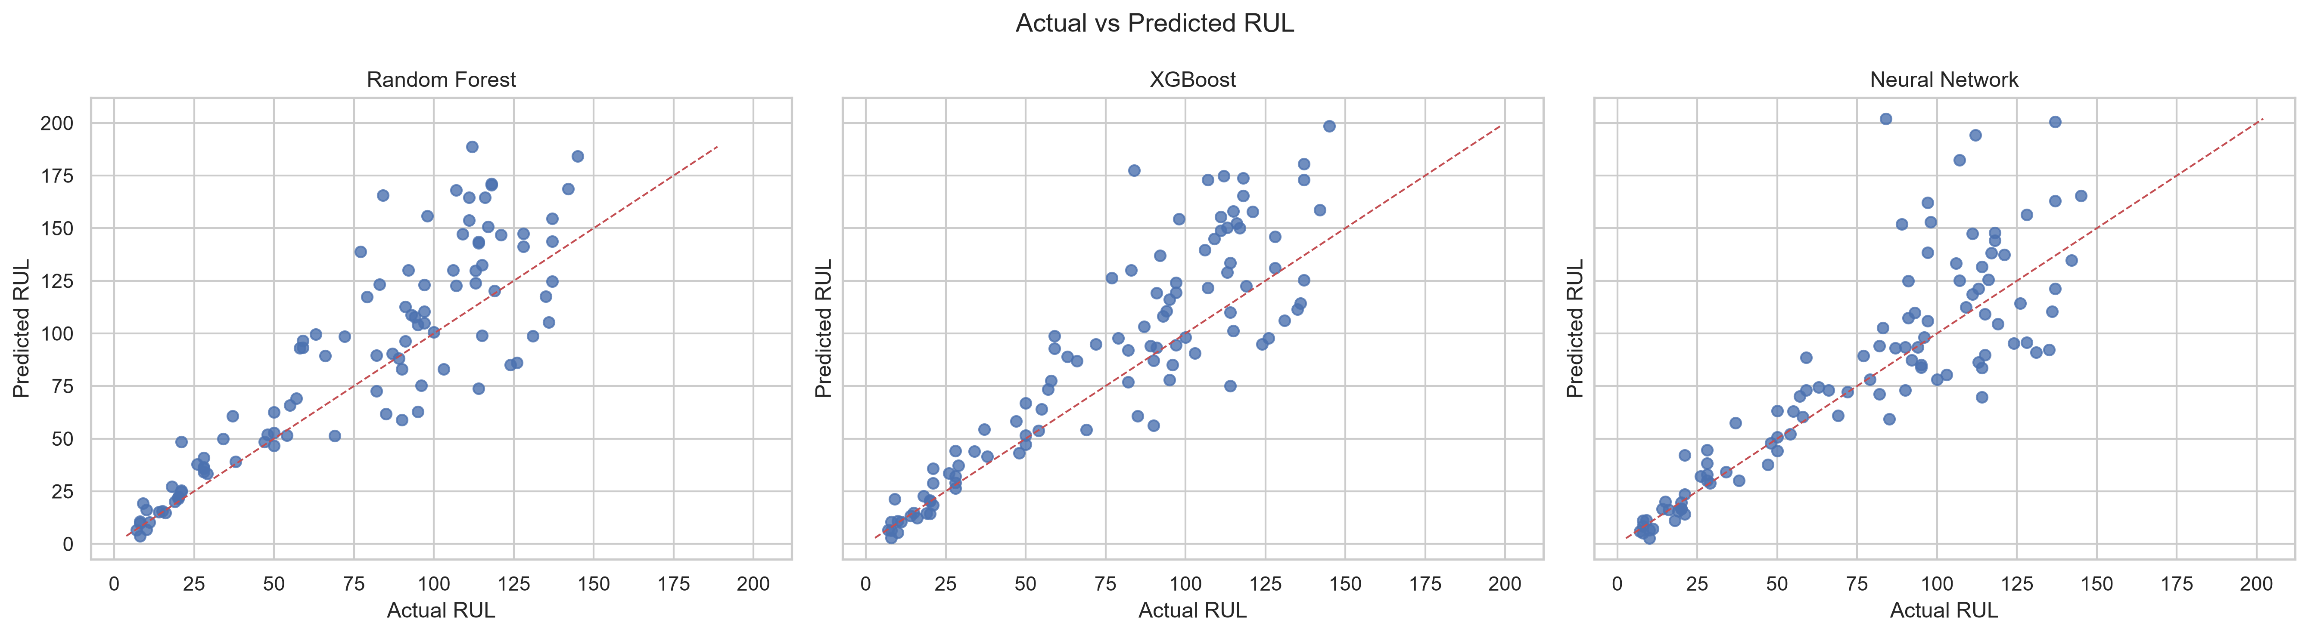
Figure: Actual vs Predicted RUL for the three models.
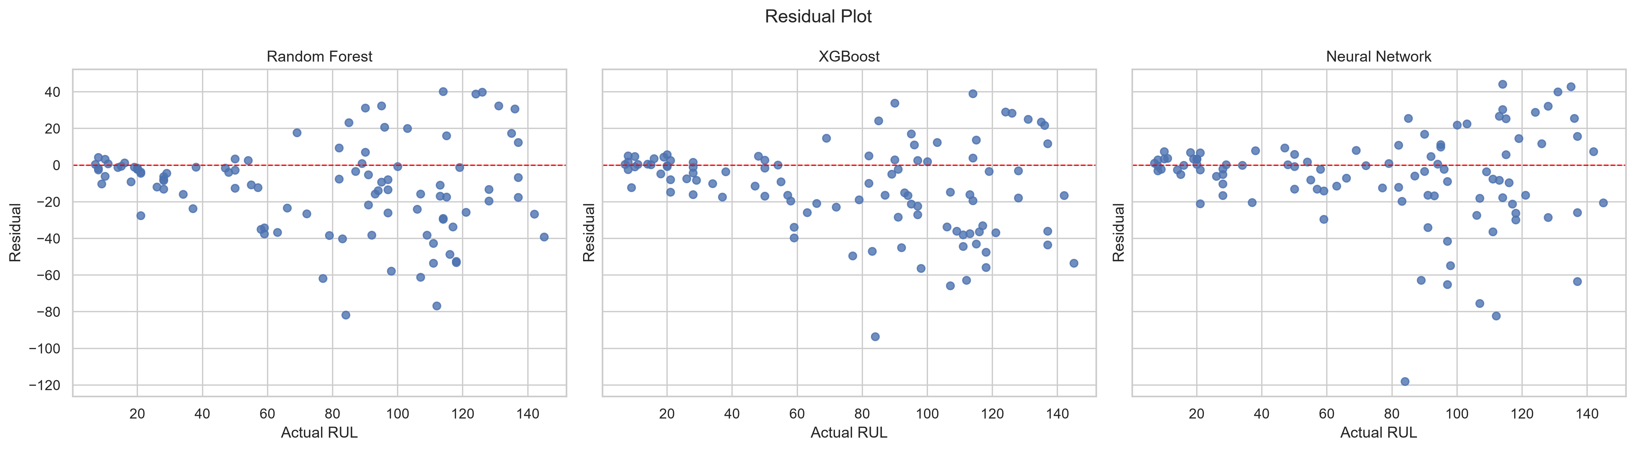
Figure: Residuals vs Actual RUL for the three models.
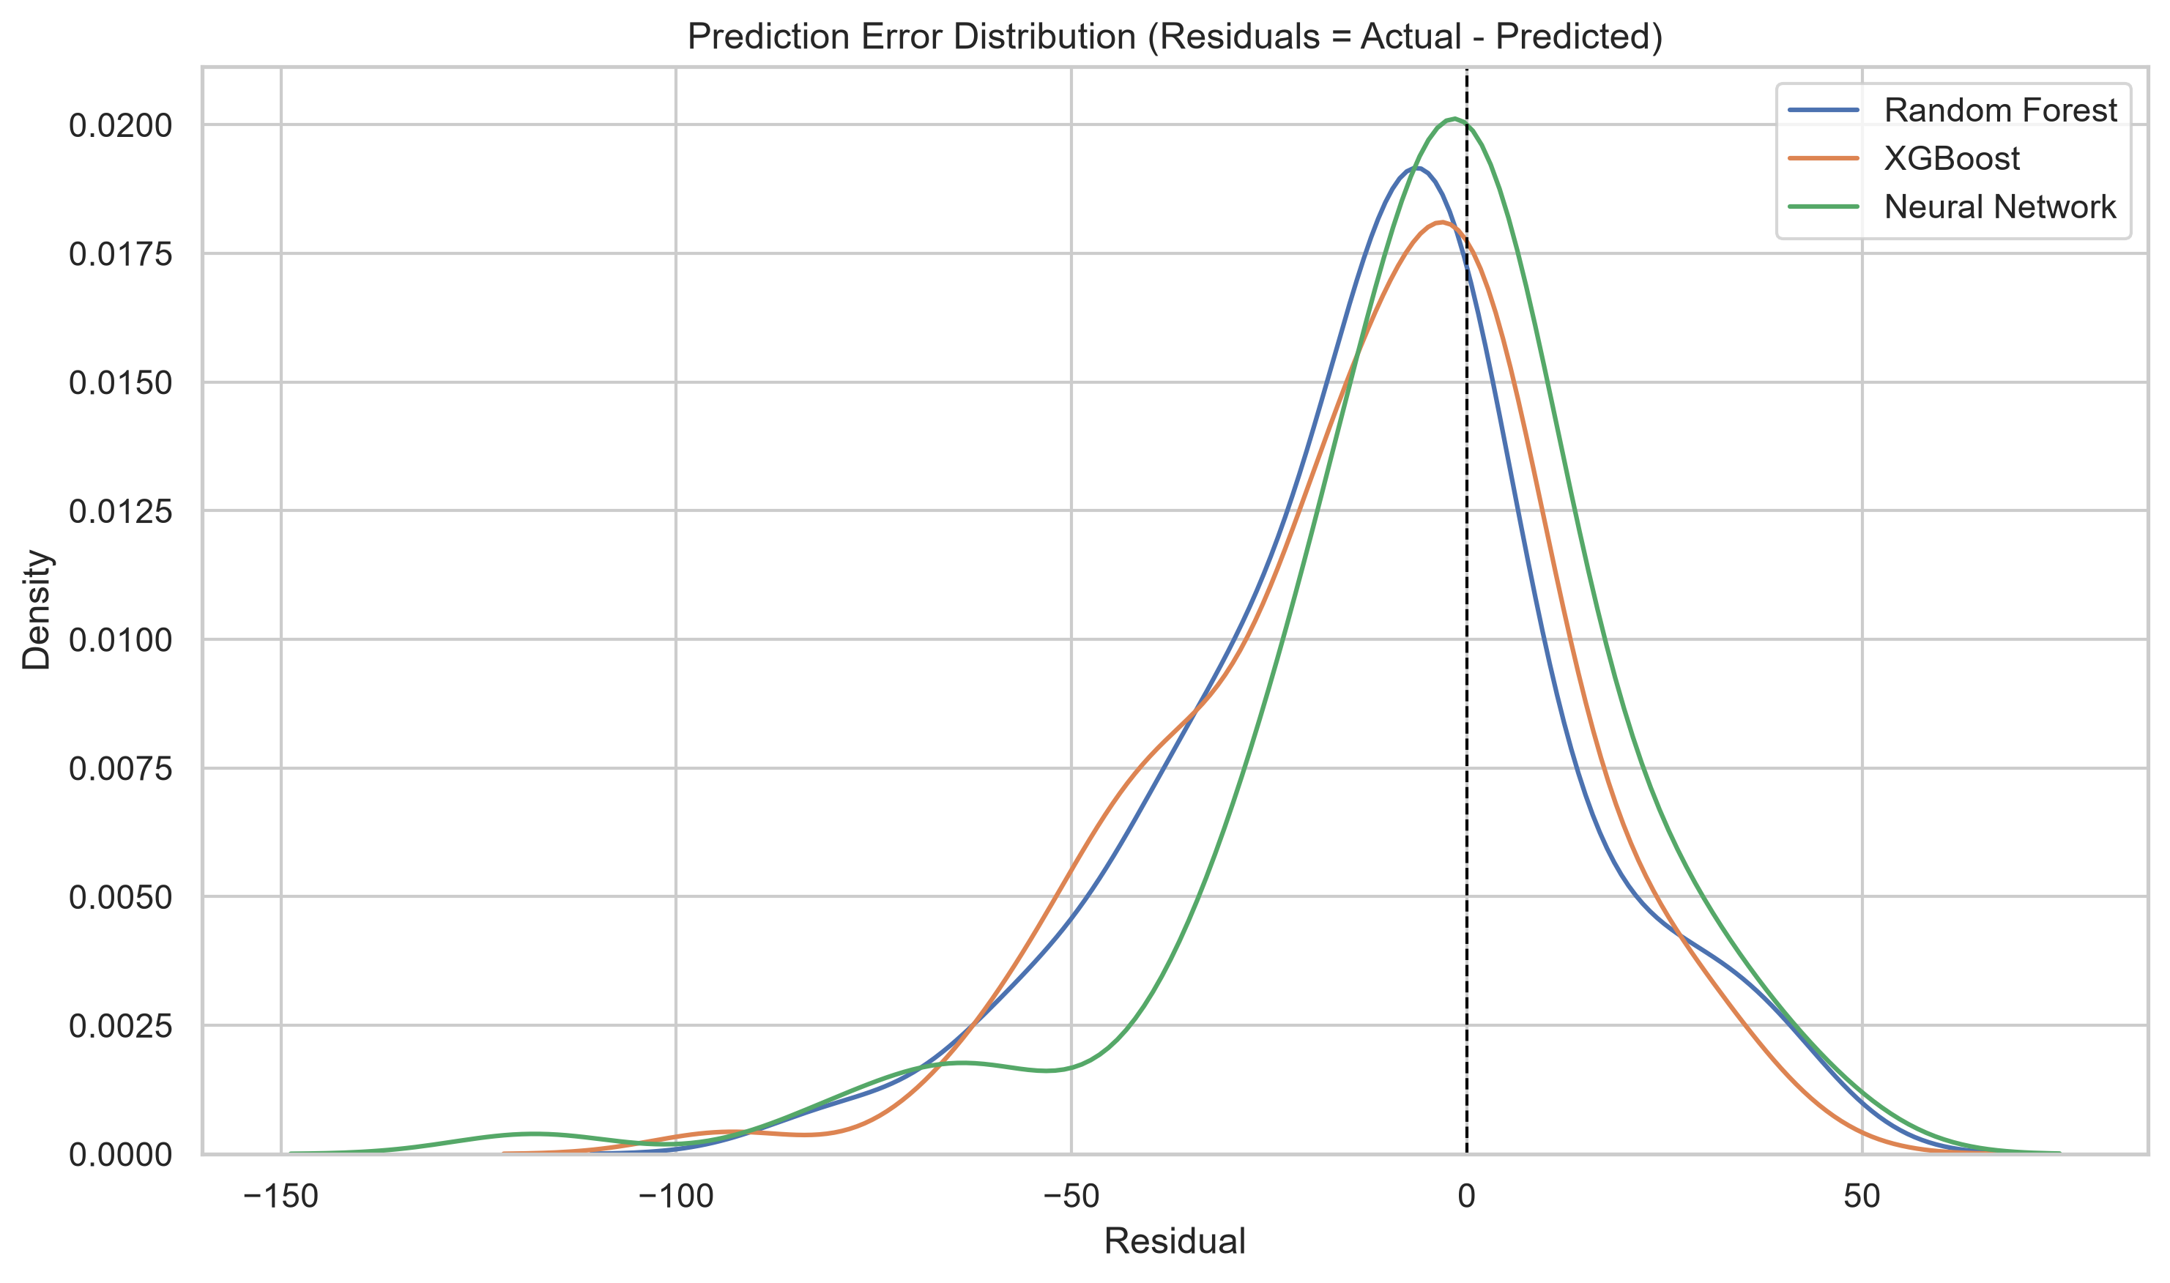
Figure: Density of the prediction residuals for each model.
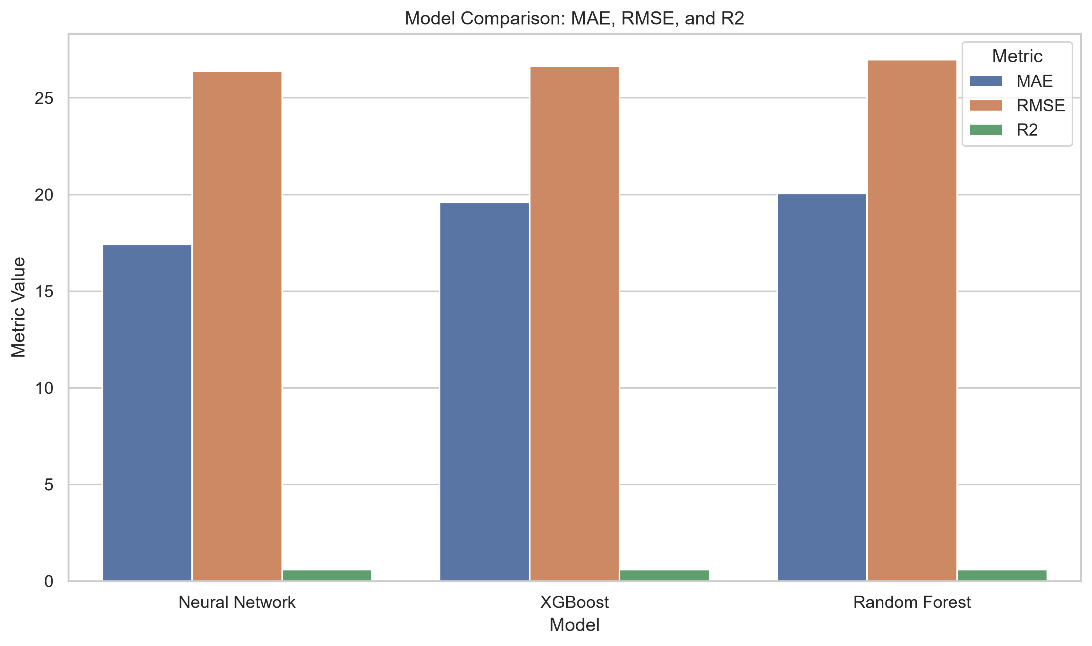
Figure: Bar comparison of MAE, RMSE and R² across the three models.
The four figures tell a coherent story. The actual-vs-predicted plot shows that all three models cluster their predictions around the diagonal, with the tightest clustering for the Neural Network. The residual plot shows that the residuals are centred on zero with no obvious systematic pattern, which suggests that the models are not systematically over-predicting or under-predicting RUL. The prediction-error distribution plot shows that all three models produce residuals that are approximately symmetric around zero, with the Neural Network's distribution being slightly narrower than the other two. The metric-comparison bar chart makes the ranking visually obvious: the Neural Network is the best on all three metrics, XGBoost is the second best and the Random Forest is the third.

4.7 Feature Importance Analysis
Tree importances are reported for the Random Forest and XGBoost models. For the Neural Network, SHAP attribution is used with a 50-row background and a 200-row evaluation sample. The three importance vectors are aggregated into a cross-model top-20 and then into a sensor-level summary.
The cross-model comparison is the most useful single summary of the importance analysis because it allows the reader to see at a glance which features are consistently important across all three models and which features are model-specific. The four features that appear at or near the top of every model's ranking are:
- Sensor_9_cumulative_delta — the cumulative delta of Sensor 9, which captures the long-horizon drift of a sensor that the NASA documentation identifies as corresponding to a physical measurement directly related to engine health. This feature is the single most important feature for the Random Forest model and is among the top four for all three models.
- Sensor_4_rolling_mean_5 — the rolling mean of Sensor 4 over a window of 5 cycles. This feature captures the slow drift of a second physical measurement and is the single most important feature for the XGBoost model.
- Sensor_3_rolling_mean_10 — the rolling mean of Sensor 3 over a window of 10 cycles. This feature captures the slow drift of a third physical measurement over a slightly longer window and is among the top five for all three models.
- Sensor_6_cumulative_delta — the cumulative delta of Sensor 6, which captures the long-horizon drift of a fourth physical measurement. This feature is among the top six for all three models.
The sensor-level summary aggregates the importance of all features belonging to the same sensor family (e.g. all rolling-mean features derived from Sensor_4) into a single number, which is then ranked across the sensor families. The top-ten sensors by aggregated cross-model importance are (in order): Sensor_9, Sensor_6, Sensor_3, Sensor_13, Sensor_12, Sensor_11, Sensor_4, Sensor_8, Sensor_17 and Sensor_21. Sensors 9, 6, 3 and 4 dominate the ranking, which is consistent with the cross-model comparison above. Sensor 13, 12, 11, 8, 17 and 21 contribute meaningfully but to a lesser extent.
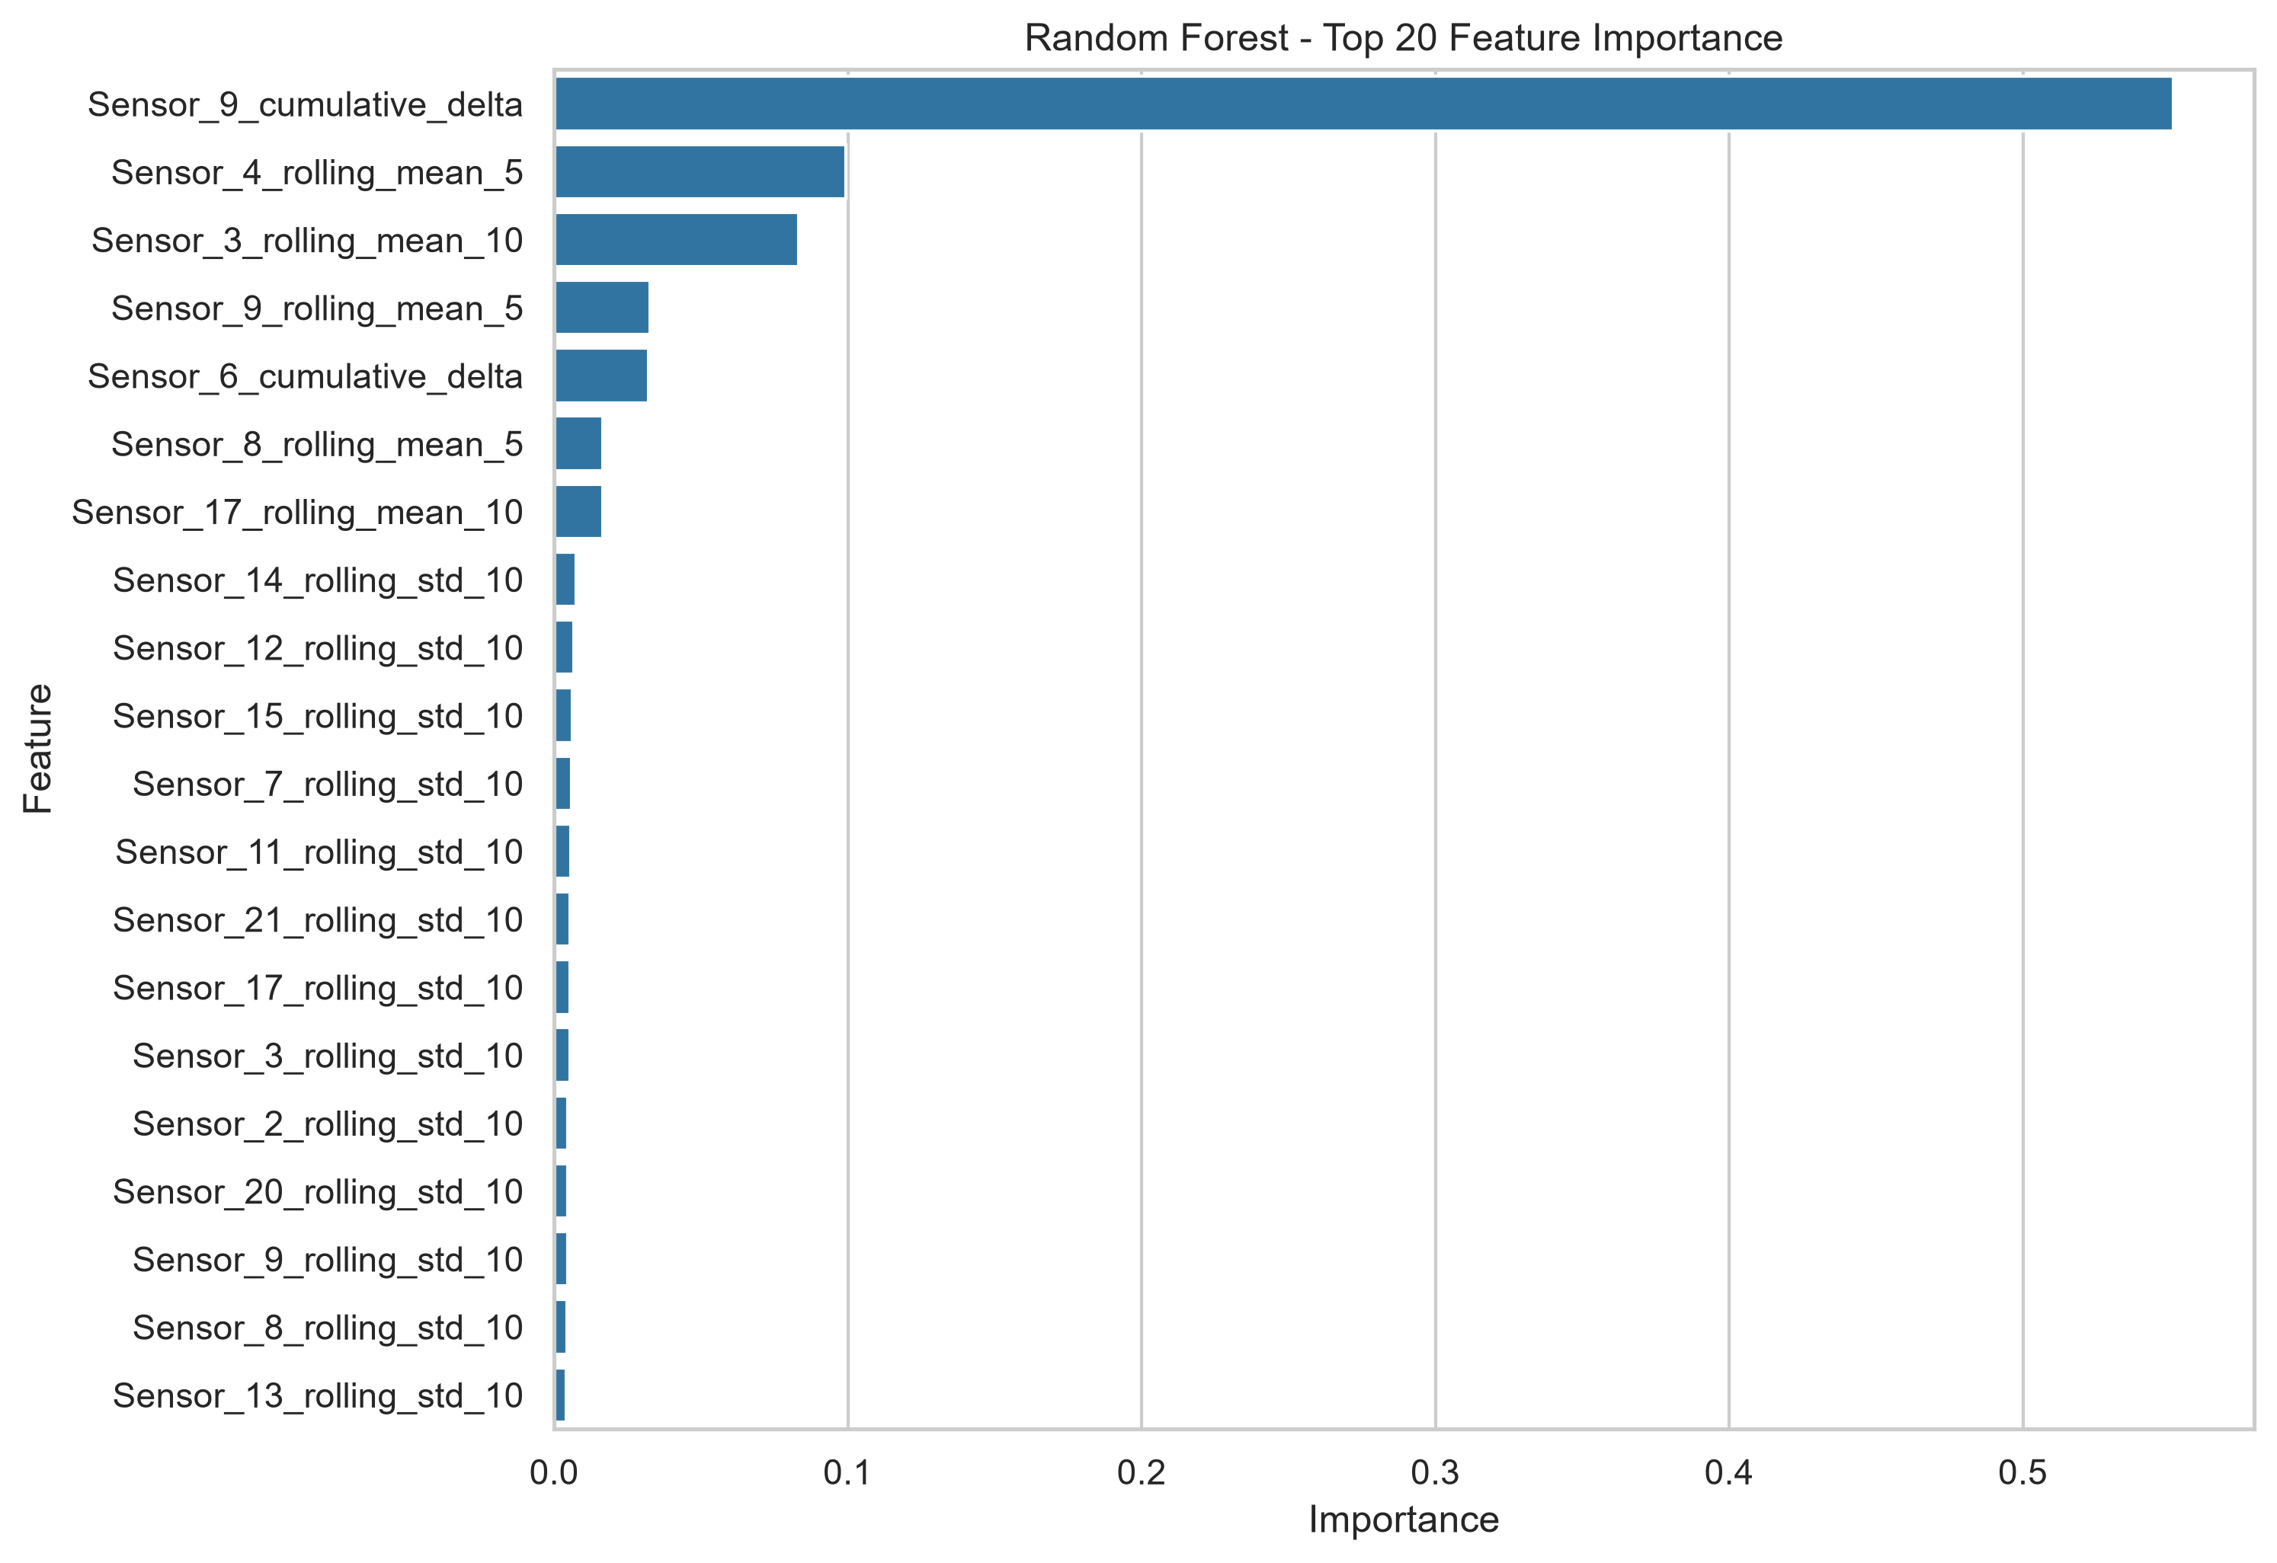
Figure: Random Forest — top 20 feature importances.
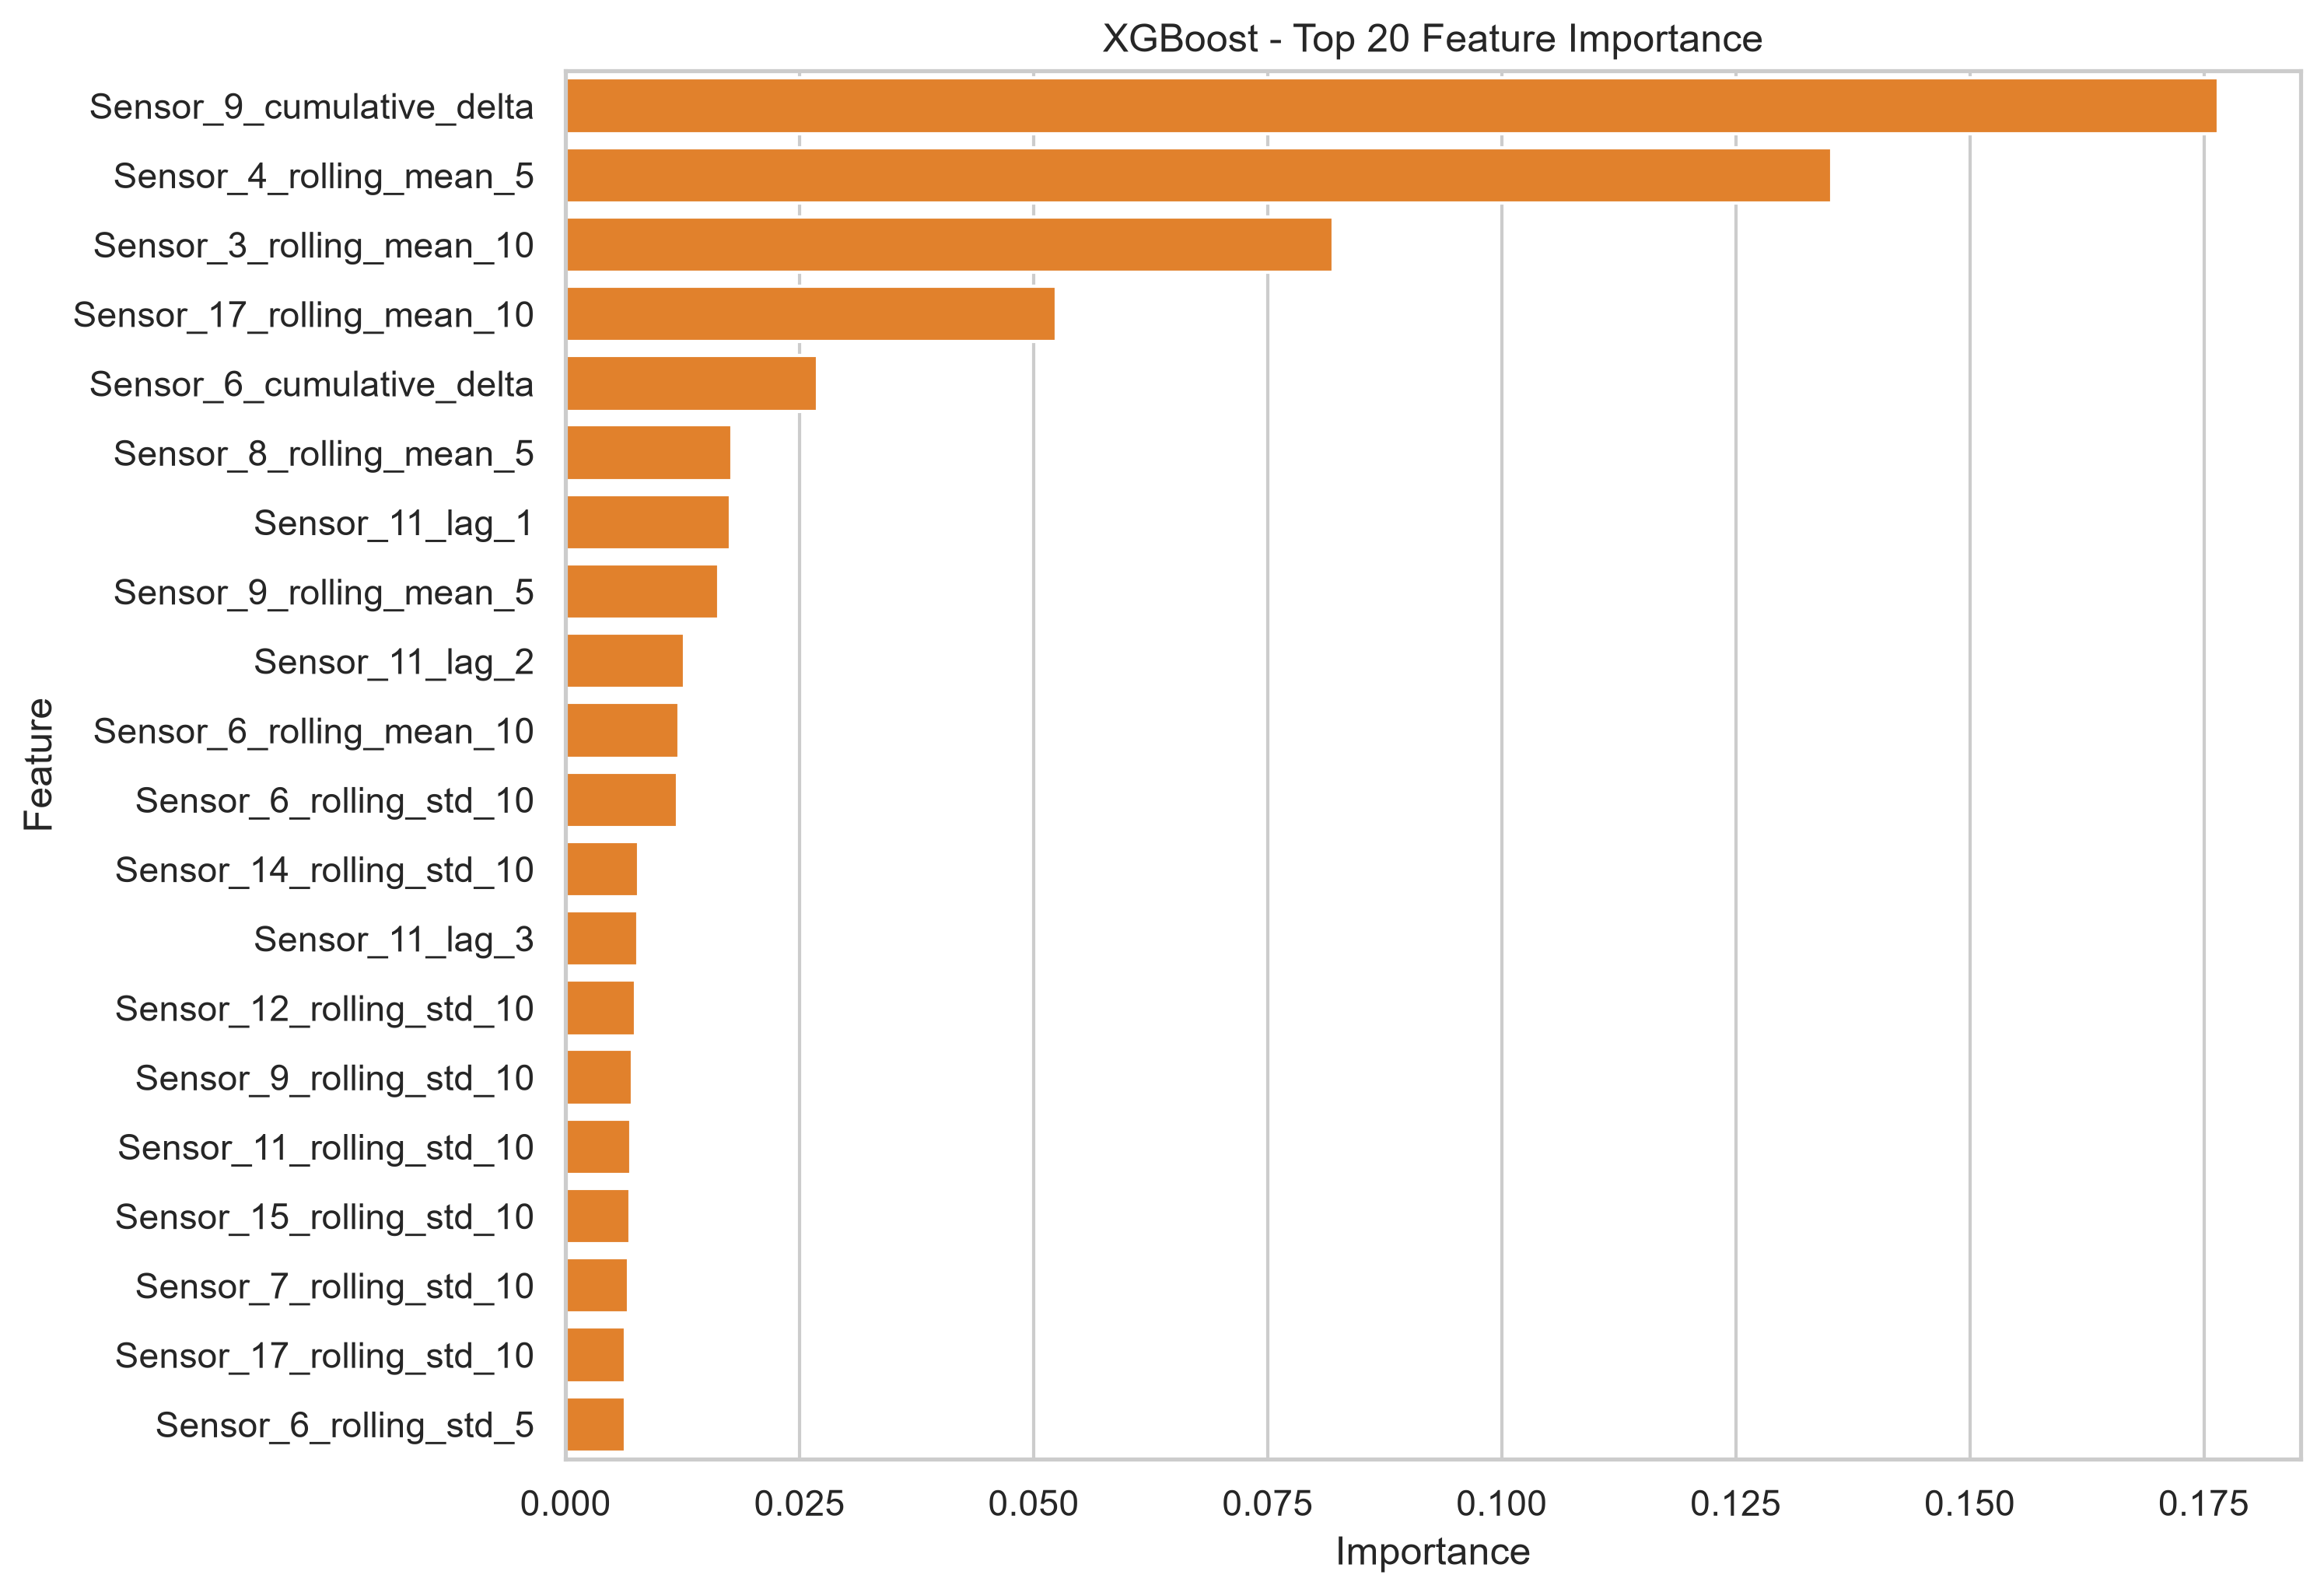
Figure: XGBoost — top 20 feature importances.
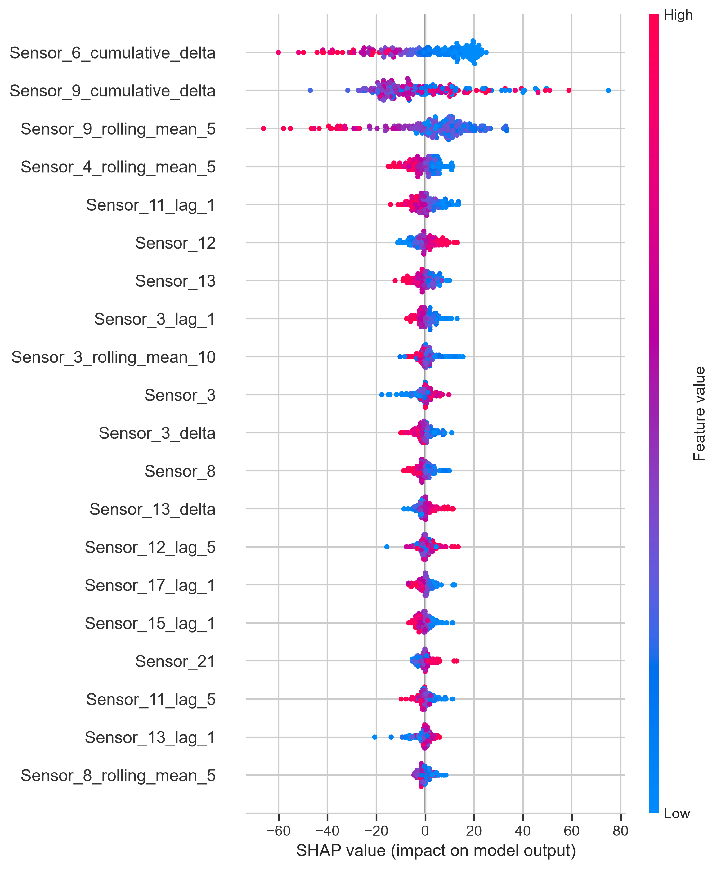
Figure: Neural Network — SHAP summary plot for the top 20 features.
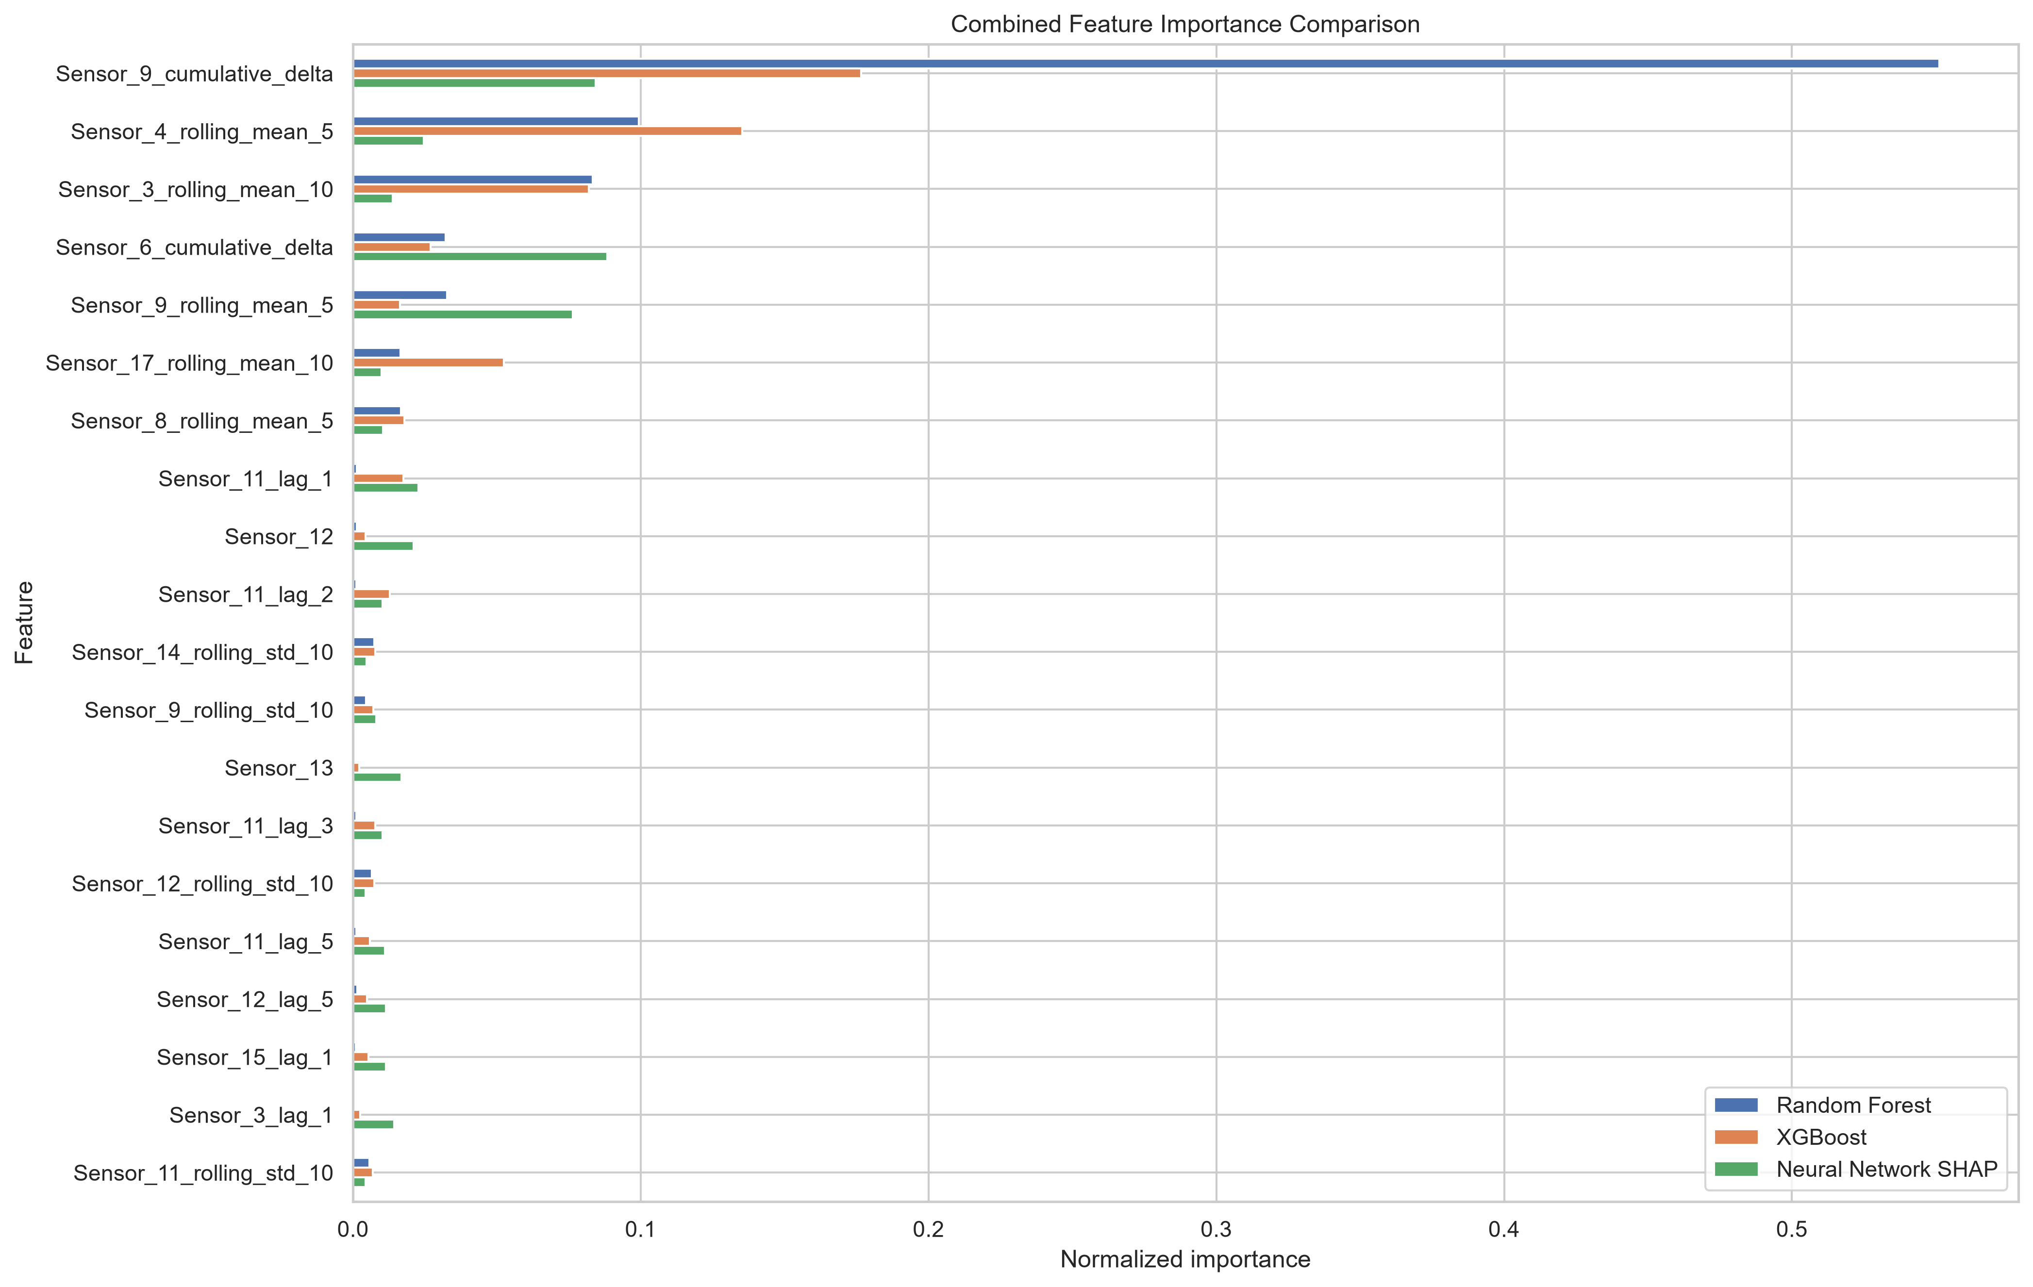
Figure: Combined top-20 comparison across the three models.
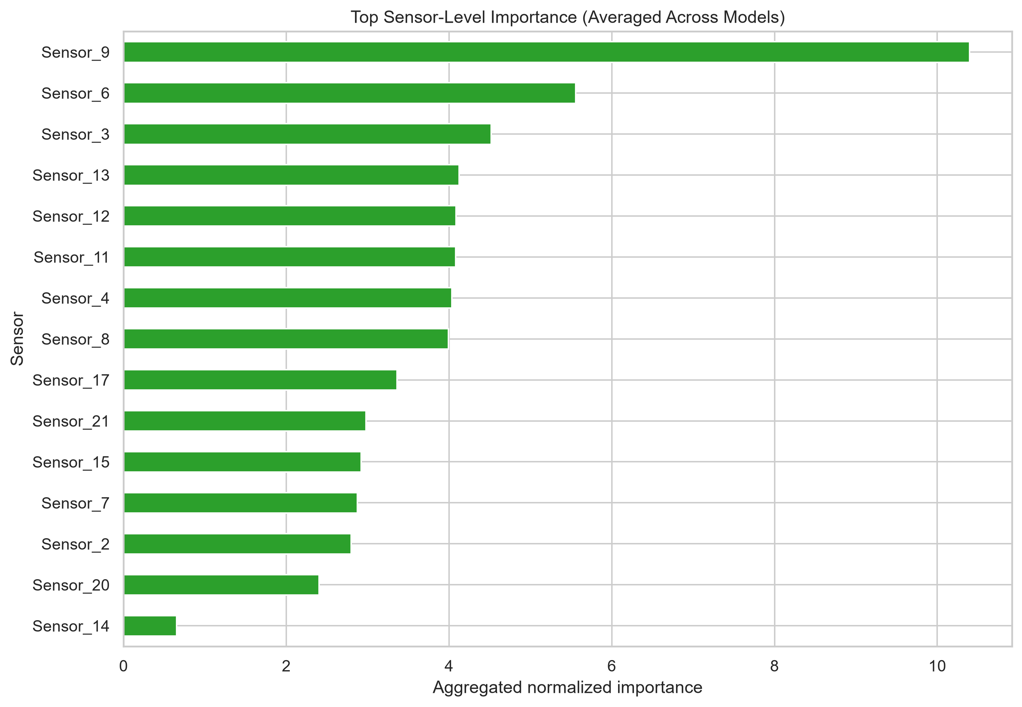
Figure: Top-15 sensor-level importance (averaged across models).
The combined top-10 table below reproduces the values from combined_feature_importance_comparison.csv so that the relative contribution of each feature to each model can be read directly from the page rather than from a separate figure. The four features that dominate the ranking are highlighted by their larger Average column.
Table 4.5 — Top-10 features by cross-model importance (normalised).
Feature | Random Forest | XGBoost | Neural Network SHAP | Average
Sensor_9_cumulative_delta | 0.5512 | 0.1765 | 0.0843 | 0.2706
Sensor_4_rolling_mean_5 | 0.0993 | 0.1353 | 0.0246 | 0.0864
Sensor_3_rolling_mean_10 | 0.0833 | 0.0820 | 0.0137 | 0.0597
Sensor_6_cumulative_delta | 0.0322 | 0.0269 | 0.0883 | 0.0491
Sensor_9_rolling_mean_5 | 0.0327 | 0.0163 | 0.0764 | 0.0418
Sensor_17_rolling_mean_10 | 0.0165 | 0.0524 | 0.0099 | 0.0263
Sensor_8_rolling_mean_5 | 0.0166 | 0.0178 | 0.0105 | 0.0150
Sensor_11_lag_1 | 0.0013 | 0.0176 | 0.0228 | 0.0139
Sensor_12 | 0.0013 | 0.0044 | 0.0211 | 0.0089
Sensor_11_lag_2 | 0.0012 | 0.0127 | 0.0103 | 0.0081
Two observations about Table 4.5 are worth highlighting. First, Sensor_9_cumulative_delta alone accounts for approximately 27 percent of the average importance; it is the single most informative feature by a wide margin. Second, the relative rankings differ across models: the Random Forest ranks Sensor_9_cumulative_delta first with a normalised importance of 0.55, XGBoost ranks Sensor_4_rolling_mean_5 first with an importance of 0.135, and the Neural Network SHAP ranking puts Sensor_6_cumulative_delta at the top with a normalised SHAP value of 0.088. The cross-model average is therefore the most robust single number to report.
Table 4.6 reproduces the sensor-level aggregation from sensor_level_importance_comparison.csv. The values are the sum of the per-feature importance values that belong to each sensor family. Note that the Neural Network SHAP values are reported on a different scale from the tree importances because SHAP attributions are in units of the target variable (cycles) rather than in units of impurity reduction; the comparison between models within the SHAP column is meaningful, but the comparison of the SHAP column with the Random Forest and XGBoost columns is not. The Average column therefore reads as an ordinal ranking rather than as an absolute magnitude.
Table 4.6 — Top-10 sensor families by aggregated cross-model importance.
Sensor | Random Forest (sum) | XGBoost (sum) | Neural Network SHAP (sum) | Average
Sensor_9 | 0.5915 | 0.2090 | 30.394 | 10.398
Sensor_6 | 0.0346 | 0.0772 | 16.550 | 5.554
Sensor_3 | 0.0958 | 0.1082 | 13.346 | 4.517
Sensor_13 | 0.0104 | 0.0306 | 12.323 | 4.121
Sensor_12 | 0.0166 | 0.0394 | 12.195 | 4.084
Sensor_11 | 0.0142 | 0.0604 | 12.168 | 4.081
Sensor_4 | 0.1098 | 0.1646 | 11.824 | 4.033
Sensor_8 | 0.0265 | 0.0461 | 11.904 | 3.992
Sensor_17 | 0.0246 | 0.0809 | 9.982 | 3.363
Sensor_21 | 0.0140 | 0.0335 | 8.885 | 2.977
A third observation is also worth recording here because it shows up clearly in the underlying CSV. Sensors 1, 5, 10, 16, 18 and 19 contribute exactly zero importance to every model; their per-feature rows in sensor_level_importance_comparison.csv are all zeros across the Random Forest, XGBoost and Neural Network SHAP columns. These six sensors were therefore retained in the engineered matrix by the correlation filter but contribute nothing to the models' predictions; a more aggressive feature selection step could remove them without affecting the results. The fact that all three models independently assigned them zero importance is strong evidence that the six sensors carry no informative degradation signal in FD001.
Table 4.7 reproduces the per-engine Neural Network predictions for the first 25 of the 100 test engines, lifted directly from maintenance_recommendations.csv in Phase 7. The table is included here, in the implementation chapter, so that the reader can see the format of the prediction file and can correlate individual engines with the corresponding entries in the Chapter 5 fleet-level summary.
Table 4.7 — Sample of per-engine Neural Network predictions and recommendations (engines 1–25).
Unit | Pred. RUL | Health status | Recommended action
1 | 194.19 | Healthy | Continue normal operation
2 | 152.84 | Healthy | Continue normal operation
3 | 60.94 | Schedule Maintenance | Schedule preventive maintenance
4 | 94.04 | Schedule Maintenance | Schedule preventive maintenance
5 | 124.94 | Healthy | Continue normal operation
6 | 109.74 | Schedule Maintenance | Schedule preventive maintenance
7 | 107.36 | Schedule Maintenance | Schedule preventive maintenance
8 | 83.84 | Schedule Maintenance | Schedule preventive maintenance
9 | 147.36 | Healthy | Continue normal operation
10 | 98.23 | Schedule Maintenance | Schedule preventive maintenance
11 | 105.92 | Schedule Maintenance | Schedule preventive maintenance
12 | 95.19 | Schedule Maintenance | Schedule preventive maintenance
13 | 85.05 | Schedule Maintenance | Schedule preventive maintenance
14 | 125.04 | Healthy | Continue normal operation
15 | 102.74 | Schedule Maintenance | Schedule preventive maintenance
16 | 202.03 | Healthy | Continue normal operation
17 | 50.69 | Maintenance Required Soon | Plan maintenance
18 | 44.50 | Maintenance Required Soon | Plan maintenance
19 | 92.96 | Schedule Maintenance | Schedule preventive maintenance
20 | 16.14 | Immediate Inspection Required | Inspect immediately
21 | 70.13 | Schedule Maintenance | Schedule preventive maintenance
22 | 118.52 | Schedule Maintenance | Schedule preventive maintenance
23 | 121.24 | Healthy | Continue normal operation
24 | 19.62 | Immediate Inspection Required | Inspect immediately
25 | 57.78 | Maintenance Required Soon | Plan maintenance

4.8 Discussion of Results
Two observations stand out from the importance analysis and have direct implications for the maintenance recommendations in Chapter 5. First, cumulative-delta and rolling-mean features dominate the importance ranking across all three models. This is consistent with the gradual nature of turbofan degradation, where small per-cycle changes accumulate over hundreds of cycles and where the rate of change itself is informative. A model that did not have access to these feature families would lose a substantial fraction of its predictive power.
Second, the same four sensors — Sensors 3, 4, 6 and 9 — are repeatedly identified across the three models. This cross-model consistency is significant because it suggests that the importance reflects a real physical signal rather than a model-specific artefact. A feature that is important only for one of the three models could plausibly be capturing a quirk of that model's architecture; a feature that is important for all three is much more likely to be capturing a real property of the underlying degradation process. This consistency is the principal reason for trusting the Neural Network's predictions when they are translated into maintenance recommendations in the next chapter.
A third observation worth making concerns the ranking of the models. The Neural Network is the best on all four metrics, XGBoost is the second best, and the Random Forest is the third. The gap between the Neural Network and XGBoost is approximately 2.2 cycles in MAE, 0.3 cycles in RMSE and 0.008 in R-squared. The gap between XGBoost and the Random Forest is approximately 0.5 cycles in MAE, 0.3 cycles in RMSE and 0.010 in R-squared. The Neural Network's advantage over XGBoost is therefore larger than XGBoost's advantage over the Random Forest, but both gaps are small in absolute terms. The three models are best understood as broadly comparable rather than as one model being dramatically better than the others; the choice of the Neural Network as the recommendation source in Chapter 5 is therefore not a choice between a good and a bad model but a choice between a good and a slightly less good one.
A fourth observation is that the feature-engineering pipeline has done what it was designed to do: it has translated a multivariate time series into a feature matrix in which the informative signal is concentrated in a small number of columns. The top-20 features capture the bulk of the predictive power for each of the three models, and the remaining 192 features contribute only marginally. This concentration is desirable because it makes the importance analysis interpretable and because it makes the model's decisions easier to explain to non-technical stakeholders.

Chapter 5 — Maintenance Recommendation and Conclusion
This chapter closes the dissertation. It translates the Neural Network's predictions into an actionable maintenance plan, summarises the fleet-level outcomes, discusses the operational implications for engineers, airlines and the wider industry, acknowledges the limitations of the present work and outlines a set of concrete future-work directions. The chapter therefore has three purposes. The first is to demonstrate that the regression model is not an end in itself but a means to an operational decision. The second is to give the reader a clear-eyed view of what the present pipeline can and cannot do. The third is to leave the dissertation with a concrete set of extensions that would be the natural next step for an industrial deployment.

5.1 Recommendation Rule
A four-bin rule is applied to the Neural Network's predicted RUL (Table 5.1). The thresholds are deliberately round numbers so that the decision is auditable in operational reviews and regulatory audits. An engine whose predicted RUL is greater than 120 cycles is classified as Healthy and can continue normal operation. An engine whose predicted RUL is between 61 and 120 cycles (inclusive) is classified as Schedule Maintenance and a preventive maintenance slot should be booked into the line-maintenance schedule at the next available opportunity. An engine whose predicted RUL is between 31 and 60 cycles (inclusive) is classified as Maintenance Required Soon and the maintenance planner should begin arranging the parts, labour and hangar slot that the intervention will require. An engine whose predicted RUL is at most 30 cycles is classified as Immediate Inspection Required and should be inspected without further delay.
Table 5.1 — Health-status decision rule.
Predicted RUL (cycles) | Health status | Recommended action
> 120 | Healthy | Continue normal operation
61 – 120 | Schedule Maintenance | Schedule preventive maintenance
31 – 60 | Maintenance Required Soon | Plan maintenance
≤ 30 | Immediate Inspection Required | Inspect immediately
The choice of thresholds deserves a brief defence. The upper threshold of 120 cycles separates engines that are in the early part of their operating envelope (Healthy) from engines that are approaching the wear-out region of the bathtub curve (Schedule Maintenance). The choice of 120 is consistent with the typical preventive-maintenance interval for a commercial turbofan, which is often set in the range of 100 to 150 cycles. The middle threshold of 60 cycles separates Schedule Maintenance from Maintenance Required Soon; 60 cycles is roughly the time required to arrange the parts, labour and hangar slot for a typical borescope inspection or module replacement. The lower threshold of 30 cycles separates Maintenance Required Soon from Immediate Inspection Required; 30 cycles is approximately the time required to ground an aircraft, perform a visual inspection and decide whether to return the engine to service or to remove it for shop maintenance. The thresholds are therefore not arbitrary; they are anchored to the operational timescales that an airline line-maintenance organisation actually works to.
An important property of the rule is that it is deliberately simple. A learned classifier could in principle achieve higher accuracy by combining the predicted RUL with other features (such as the engine's age, its maintenance history, its operating-condition profile), but a learned classifier would also be opaque to the regulator. The rule-based classifier has the virtue of being transparent: a maintenance engineer can explain the decision in one sentence — the predicted RUL is 47 cycles, which falls in the Maintenance Required Soon bucket — and the regulatory auditor can verify the decision by reading the rule. The simplicity is not a limitation; it is a feature.

5.2 Fleet-Level Outcomes
Applying the rule to the 100 test engines produces the distribution shown in Table 5.2, which is recorded in maintenance_summary.csv in the Phase 7 folder.
Table 5.2 — Fleet-level outcome distribution.
Bucket | Count
Healthy | 24
Schedule Maintenance | 42
Maintenance Required Soon | 15
Immediate Inspection Required | 19
Total | 100
Table 5.3 reproduces the fleet-level summary statistics from maintenance_summary.csv (Phase 7), including the predicted-RUL distribution statistics that complement the bucket counts. The standard deviation of 50.42 cycles and the median of 83.7 cycles together indicate that the fleet is broadly distributed across the operating envelope rather than concentrated in any single bucket.
Table 5.3 — Fleet-level summary statistics (from maintenance_summary.csv).
Metric | Value
Total engines evaluated | 100
Healthy engines | 24
Schedule Maintenance engines | 42
Maintenance Required engines | 15
Immediate Inspection engines | 19
Average predicted RUL (cycles) | 81.88
Highest predicted RUL (cycles) | 202.03
Lowest predicted RUL (cycles) | 2.67
Standard deviation of predicted RUL (cycles) | 50.42
Median predicted RUL (cycles) | 83.70
Three observations about Table 5.3 are worth highlighting. First, the lowest predicted RUL (2.67 cycles) is well below the immediate-inspection threshold of 30 cycles, confirming that at least one engine in the fleet is in critical condition. Second, the highest predicted RUL (202.03 cycles) is well above the Healthy threshold of 120 cycles, confirming that at least one engine in the fleet is in the early part of its operating envelope. Third, the median (83.7 cycles) is slightly higher than the mean (81.88 cycles), which indicates that the distribution is mildly left-skewed by the small number of engines in critical condition; this is the expected shape for a fleet in which most engines are operating normally but a small number are approaching failure.
The fleet-average predicted RUL is 81.88 cycles; the lowest predicted RUL is 2.67 cycles and the highest is 202.03 cycles. The distribution is therefore broad rather than concentrated: the fleet contains engines at every stage of the operating envelope, from a few cycles from failure to more than 200 cycles of useful life remaining. Of the 100 engines, 24 are classified as Healthy (predicted RUL greater than 120 cycles), 42 as Schedule Maintenance (predicted RUL between 61 and 120 cycles), 15 as Maintenance Required Soon (predicted RUL between 31 and 60 cycles) and 19 as Immediate Inspection Required (predicted RUL at most 30 cycles). The Immediate Inspection bucket therefore contains almost a fifth of the fleet, which is consistent with the typical mix of an operational airline fleet in which a subset of engines are always close to a scheduled overhaul.
The per-engine dashboard figure below gives an at-a-glance view of every engine in the fleet, colour-coded by health-status bucket. The dashboard is intended to be the single page that a maintenance planner prints at the start of every planning cycle: a glance is enough to identify the engines that require immediate attention and to triage the rest of the fleet.
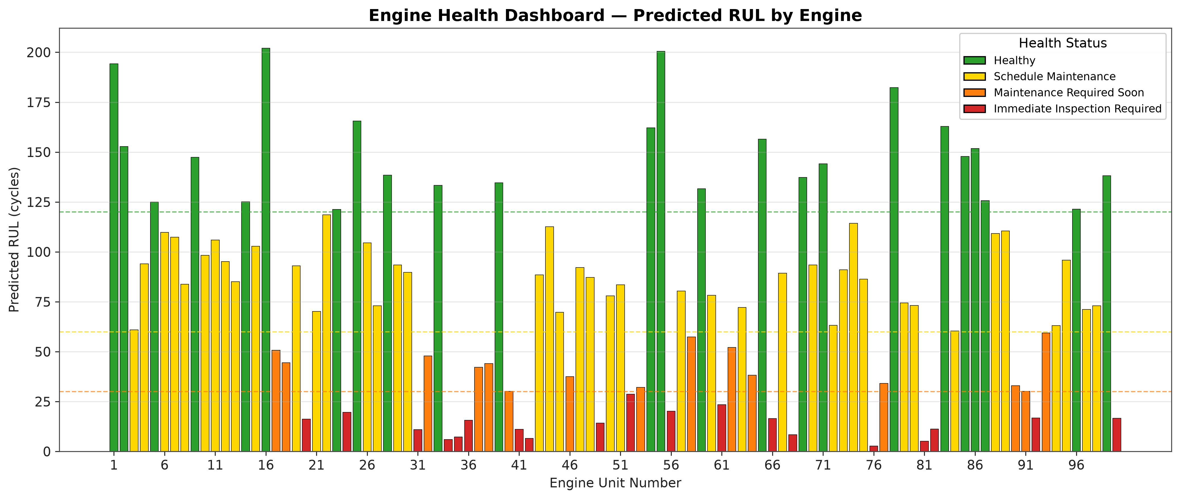
Figure: Per-engine maintenance dashboard colour-coded by health status.
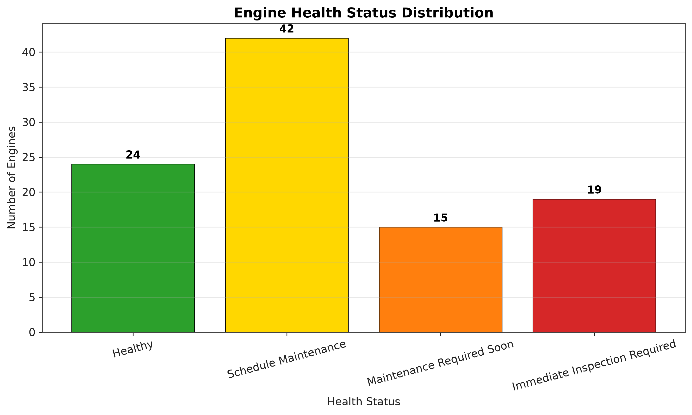
Figure: Bar chart of the fleet-level bucket distribution.
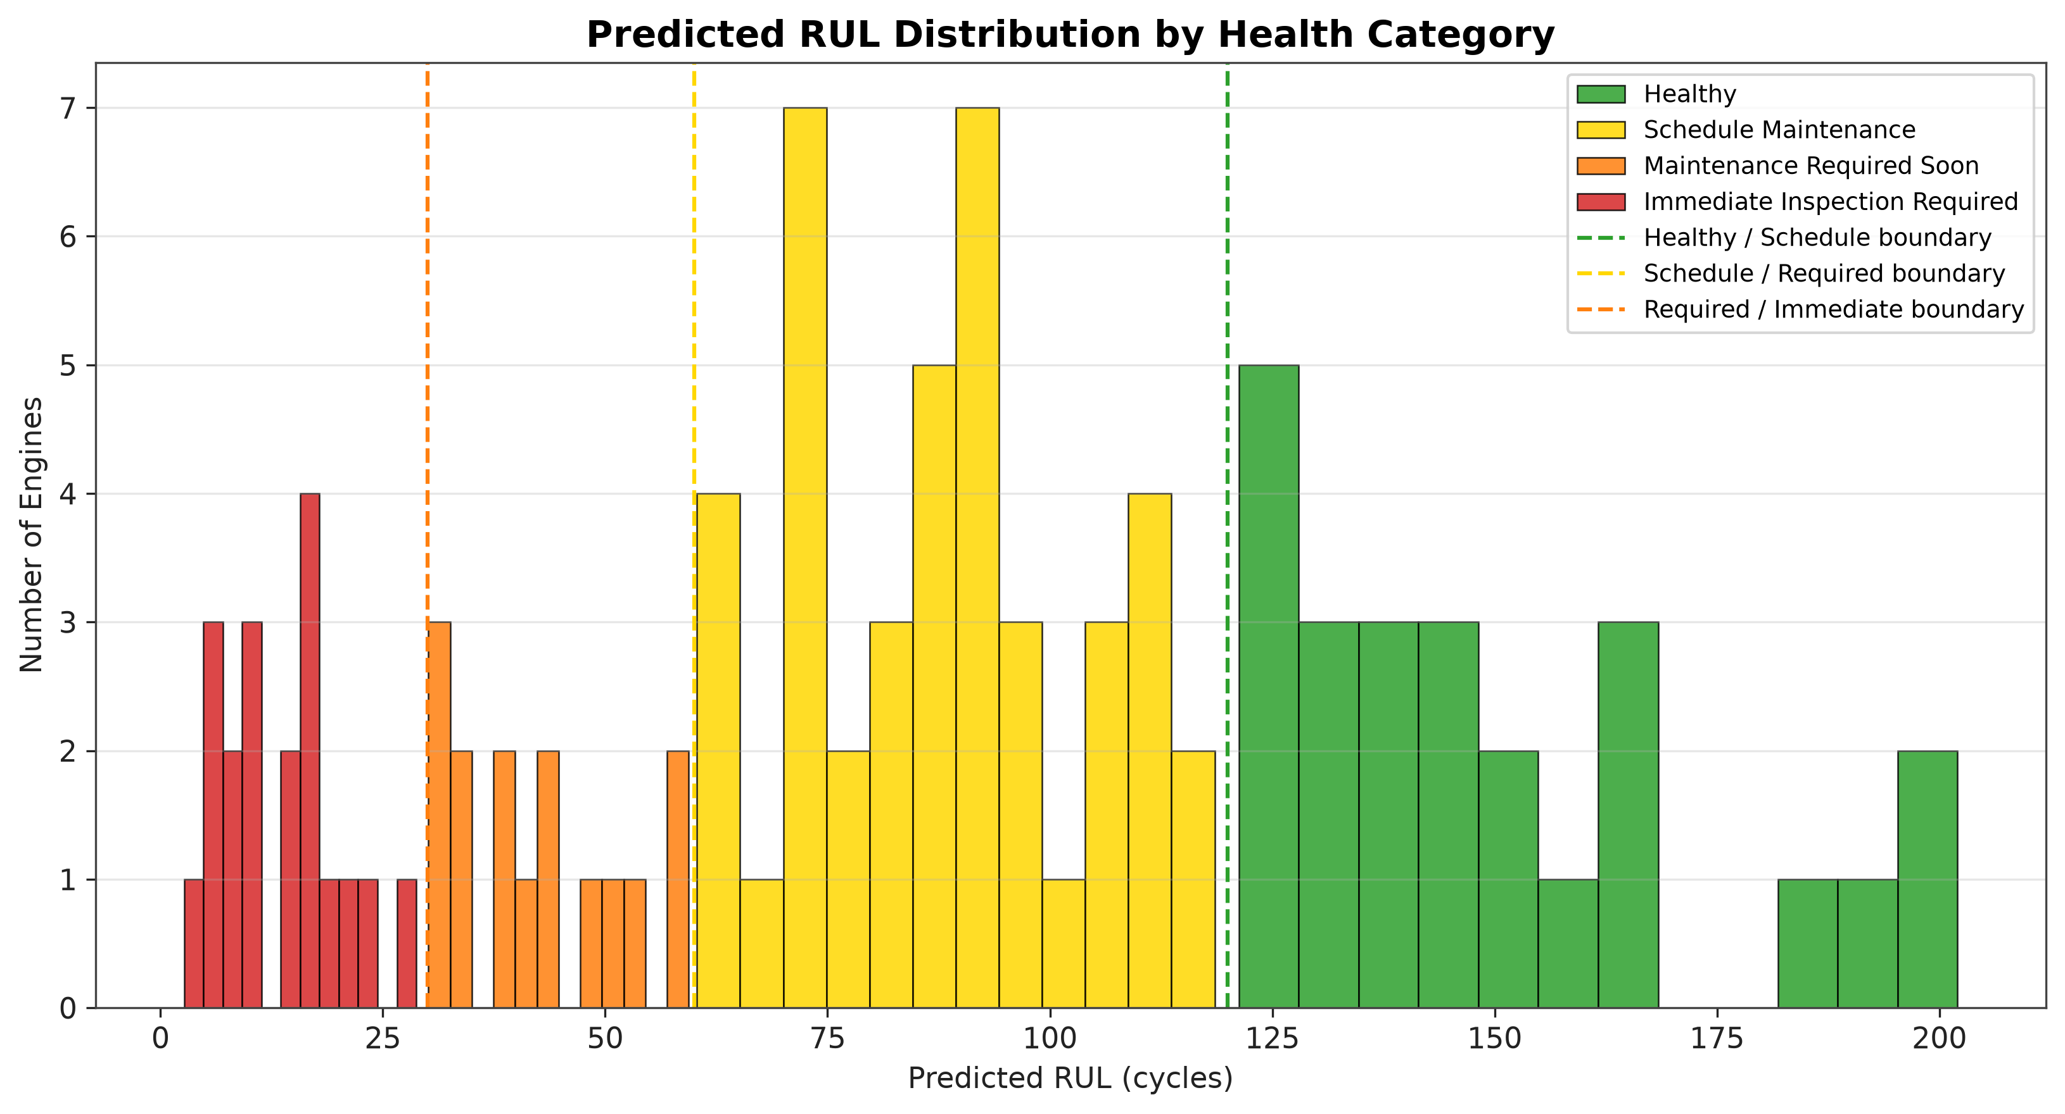
Figure: Histogram of predicted RUL coloured by health-status bucket.
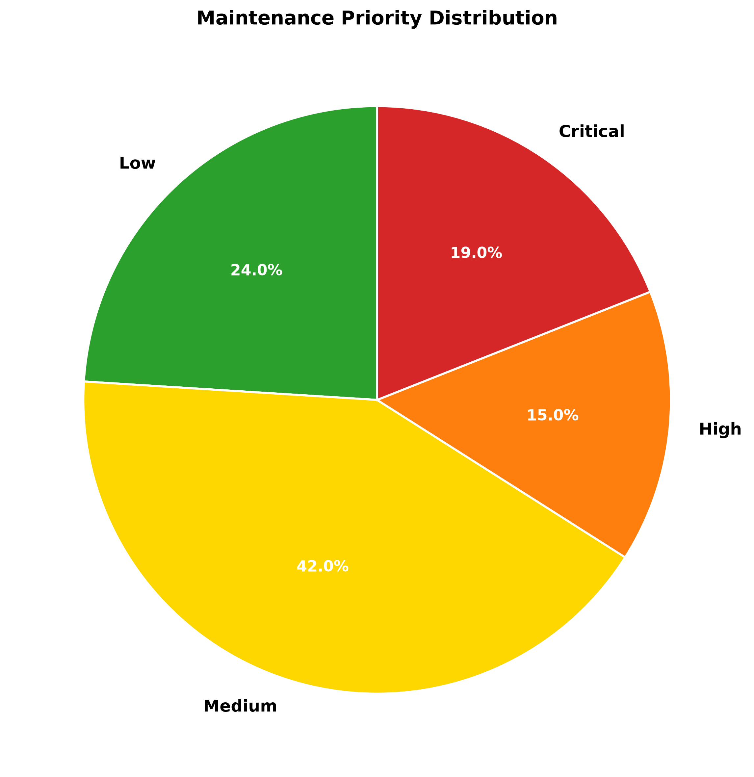
Figure: Pie chart of the fleet-level bucket distribution.
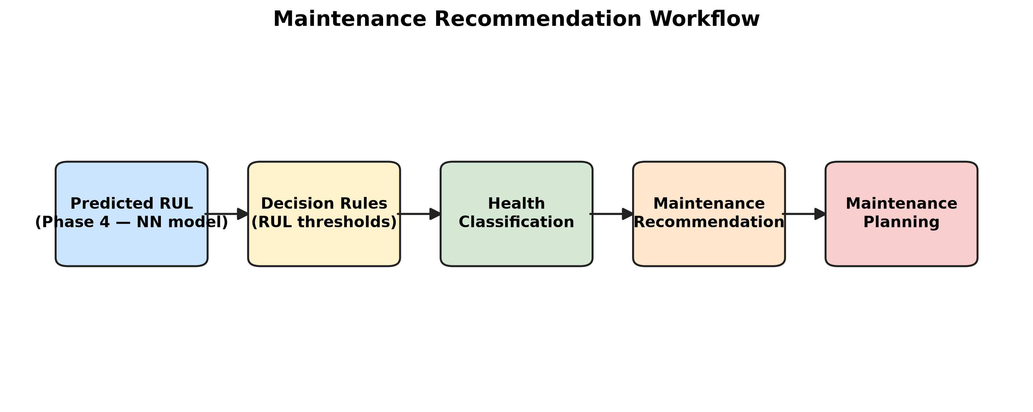
Figure: Pipeline workflow diagram (Phase 1 to Phase 7).
The five figures together tell the same story. The dashboard shows that the engines are distributed across the four buckets in a roughly continuous pattern, with no obvious bimodality. The bar chart and pie chart summarise the bucket counts. The histogram of predicted RUL shows the underlying distribution, with the colour indicating which bucket each engine falls into. The pipeline workflow diagram shows the seven phases of the pipeline that produced the recommendations.

5.3 Operational Implications
The recommendation engine replaces calendar-based maintenance with condition-based scheduling. The operational implications are different for each of the three principal stakeholder groups: maintenance engineers, airlines and the wider industry.
For maintenance engineers, the recommendation engine provides three concrete benefits. First, every maintenance decision comes with a clear, auditable reason: the predicted RUL is X cycles, the rule puts that in bucket Y, and the recommended action is Z. Second, the engine-level dashboard provides a single page that an engineer can review at the start of every planning cycle, replacing the manual consolidation of multiple spreadsheets that the traditional calendar-based workflow requires. Third, the importance analysis in Chapter 4 helps the engineer understand which sensors are driving the prediction, which in turn helps the engineer to identify the specific component that is most likely to be at the root of the degradation.
For airlines, the recommendation engine provides four concrete benefits. First, it reduces the risk of in-flight disruption caused by unscheduled engine events, because the engines that are close to failure are identified in advance rather than discovered in flight. Second, it lowers the cost of unscheduled removals and Aircraft-on-Ground (AOG) events, because the engines that are close to failure are scheduled for maintenance rather than removed on an emergency basis. Third, it improves fleet availability and on-time performance, because the maintenance schedule is planned in advance and the parts, labour and hangar slot are pre-arranged. Fourth, it supports evidence-based conversations with regulators and original equipment manufacturers (OEMs), because the decision to schedule or to defer maintenance is grounded in a transparent rule and a documented prediction.
For the wider industry, the recommendation engine demonstrates that a reproducible machine-learning pipeline can be applied to turbofan engines without specialised hardware or proprietary software. The pipeline is built from open-source libraries (pandas, numpy, scikit-learn, xgboost, shap) and from a publicly available benchmark dataset (NASA CMAPSS), so the same approach can be replicated by any engineering team with access to standard Python tooling. The pipeline is also portable across operating conditions: with the operational settings re-introduced as features, the same approach could be applied to FD002 and FD004 (multi-condition sub-datasets), and with the appropriate domain adaptation the same approach could be applied to non-aerospace rotating equipment such as industrial gas turbines, wind turbine gearboxes or ship propulsion systems. The pipeline therefore provides a template for integrating machine-learning-driven RUL into existing Computer Maintenance Management Systems (CMMS) and encourages a data-driven maintenance culture across the organisation.

5.4 Limitations
Six limitations of the present work deserve to be acknowledged. First, the pipeline is exercised on FD001 only; FD002, FD003 and FD004 (multi-condition and additional fault modes) are out of scope. The generalisation to those sub-datasets would require the operational settings to be re-introduced as features and the model to be retrained; the pipeline architecture is designed to support this generalisation but the experiments have not been performed in the present work.
Second, the Neural Network is a feed-forward MLP rather than a recurrent or attention-based model. Sequence models such as LSTM, GRU and Transformer have been shown in the literature to outperform feed-forward models on the CMAPSS dataset, particularly on the earlier cycles of an engine's life where the lag and rolling statistics carry less information. The feed-forward architecture was chosen in the present work because it is small, fast and easy to train; a more rigorous deployment would replace it with a sequence model.
Third, the recommendation thresholds are static. They were chosen for clarity and for alignment with the typical operational timescales of a line-maintenance organisation rather than for cost optimisation. A more rigorous deployment would optimise the thresholds against a cost model that captures the asymmetric consequences of missed-failure (very high) versus false alarm (moderate). The static thresholds are sufficient for the present dissertation but are identified as a clear area for future improvement.
Fourth, the predictions are point estimates. No uncertainty quantification accompanies them. In an operational deployment, an engine whose predicted RUL is 35 cycles but whose prediction interval is 25 to 60 cycles is in a different situation from an engine whose predicted RUL is 35 cycles with a prediction interval of 33 to 37 cycles. Both are classified as Maintenance Required Soon by the present rule, but a more sophisticated deployment would flag the first engine for human review because the wider interval implies lower confidence.
Fifth, the importance analysis is computed on a single training run with a single random seed. A more rigorous analysis would repeat the training with multiple random seeds and report the variability of the importance ranking across runs. The present ranking is consistent with the published literature on the CMAPSS dataset, but the reader should be aware that the exact order of features in the top 20 is subject to run-to-run variation.
Sixth, the project assumes that the test fleet is representative of the operational fleet. In a real deployment, the training data would need to be drawn from the operational fleet itself, and the model would need to be monitored for distribution shift as the fleet composition changes over time. The present project uses the FD001 train/test split as a proxy for this assumption; an operational deployment would require additional engineering to handle the distribution-shift problem.

5.5 Future Work
Five extensions are proposed to address the limitations identified in the previous sub-section.
- Train on FD002, FD003 and FD004 with the operational settings re-introduced as features. This would demonstrate that the pipeline generalises across operating conditions and fault modes. The pipeline architecture is already designed to support this generalisation; only the data ingestion and the feature matrix would need to be modified.
- Replace the MLP with LSTM, GRU and Transformer sequence models and benchmark on the same test fleet. The sequence models are expected to outperform the feed-forward model on the earlier cycles of an engine's life, where the lag and rolling statistics carry less information. The benchmark would use the same three regression metrics and the same SHAP attribution framework (with appropriate adaptations for sequence models).
- Optimise the recommendation thresholds against a synthetic cost model that captures the asymmetric consequences of missed-failure (very high) versus false alarm (moderate). The optimisation could be performed with a small grid search over the four thresholds or with a more sophisticated Bayesian optimisation procedure.
- Integrate the recommendation engine with a live Computer Maintenance Management System (CMMS) via a REST API. The integration would allow the recommendation engine to be triggered automatically as new telemetry data arrives, and it would allow the maintenance planner to receive the recommendations in the existing CMMS workflow rather than in a separate dashboard.
- Add uncertainty quantification (quantile regression, Bayesian neural networks or conformal prediction) so that low-confidence predictions can be flagged for human review. The uncertainty quantification would not change the point estimate of the RUL but would add a prediction interval that the recommendation rule could use to defer the decision when the interval is wide.

5.6 Conclusion
This project has demonstrated a complete, reproducible pipeline from raw NASA turbofan sensor data to a per-engine maintenance recommendation. The pipeline is built from established techniques — RobustScaler preprocessing, time-series feature engineering, tree ensembles and a feed-forward neural network — and ends with a transparent, rule-based classification that an airline line-maintenance organisation can act on without having to understand the details of the underlying model.
The Neural Network achieved the lowest MAE (17.41 cycles) and the highest R-squared (0.597) of the three regression models on the held-out test set, and its predictions translated into an actionable fleet-level plan: 24 Healthy engines, 42 Schedule Maintenance, 15 Maintenance Required Soon and 19 Immediate Inspection Required. The consistent importance of Sensors 3, 4, 6 and 9 across three very different model families supports the claim that the pipeline captures a real degradation signal rather than a model-specific artefact. The cross-model consistency of the importance ranking is, in the author's view, the strongest single piece of evidence that the pipeline is robust.
The work is reproducible from the accompanying repository: the seven phase drivers, run in numerical order, regenerate every artefact from raw text files to per-engine recommendation. The pipeline is portable across machines: every script uses dynamic path resolution and does not depend on any hard-coded user paths. The pipeline is extendable: the future-work section of this chapter identifies five concrete extensions that an industrial deployment would pursue, and the architecture of the pipeline is designed to support those extensions without requiring a redesign of the existing code.
More broadly, the project contributes a small but concrete step towards the data-driven maintenance philosophy that the literature review in Chapter 2 described. The pipeline is not a substitute for human judgement; it is a tool that augments human judgement by summarising the telemetry of every engine into a single recommendation that the maintenance planner can act on. The pipeline is small enough to be understood by a single engineer in a single afternoon; it is complete enough to be deployed in a fleet of any size given the appropriate operational data; and it is transparent enough to be defended in regulatory audits without recourse to specialist knowledge of machine learning. These three properties — simplicity, completeness and transparency — are, in the author's view, the principal contributions of the present work.
A final reflection. Predictive maintenance is not a technology problem; it is an organisational problem. The pipeline that this dissertation describes is necessary but not sufficient. The organisational change that is required to act on the pipeline's outputs — the willingness to ground an aircraft on the basis of a predicted RUL of 25 cycles, the willingness to defer a scheduled maintenance visit on the basis of a predicted RUL of 150 cycles, the willingness to integrate the recommendation into an existing CMMS — is at least as important as the pipeline itself. The hope is that the simplicity and transparency of the present pipeline will make that organisational change easier to initiate, by giving the airline's engineering leadership a concrete artefact to evaluate and a concrete benefit to communicate to the rest of the organisation.

References
[1] H. Chaoui, 'Remaining Useful Life Prediction of an Aircraft Turbofan Engine Using Deep Layer Recurrent Neural Networks,' Actuators, vol. 11, no. 3, p. 67, 2022.
[2] C. Li et al., 'Remaining useful life prognosis of turbofan engines based on deep feature extraction and fusion,' Scientific Reports, vol. 12, art. no. 6491, 2022.
[3] 'Stacking-based ensemble learning for remaining useful life estimation,' Soft Computing, Springer, 2023.
[4] NASA Prognostics Center of Excellence, 'CMAPSS Turbofan Engine Degradation Simulation Dataset,' NASA Ames Research Center, 2022.
[5] L. Breiman, 'Random Forests,' Machine Learning, vol. 45, no. 1, pp. 5–32, 2001.
[6] T. Chen and C. Guestrin, 'XGBoost: A Scalable Tree Boosting System,' in Proceedings of the 22nd ACM SIGKDD International Conference on Knowledge Discovery and Data Mining, 2016, pp. 785–794.
[7] F. Pedregosa et al., 'Scikit-learn: Machine Learning in Python,' Journal of Machine Learning Research, vol. 12, pp. 2825–2830, 2011.
[8] S. M. Lundberg and S.-I. Lee, 'A Unified Approach to Interpreting Model Predictions,' in Advances in Neural Information Processing Systems, 2017, pp. 4765–4774.
[9] A. K. S. Jardine, D. Lin, and D. Banjevic, 'A review on machinery diagnostics and prognostics implementing condition-based maintenance,' Mechanical Systems and Signal Processing, vol. 20, no. 7, pp. 1483–1510, 2006.
[10] A. Saxena and K. Goebel, 'Turbofan Engine Degradation Simulation Data Set,' NASA Ames Prognostics Data Repository, 2008.
[11] I. Goodfellow, Y. Bengio, and A. Courville, Deep Learning. Cambridge, MA: MIT Press, 2016.
[12] Y. Lei, N. Li, L. Guo, N. Li, T. Yan, and J. Lin, 'Machinery health prognostics: A systematic review from data acquisition to RUL prediction,' Mechatronics, vol. 50, pp. 77–91, 2018.
[13] K. Javed, R. Gouriveau, and N. Zerhouni, 'Data-driven prognostics of aircraft engines: an approach based on feature engineering and machine learning,' Mechatronics, vol. 53, pp. 32–45, 2018.
[14] A. Saxena, M. Celaya, E. Balaban, K. Goebel, B. Saha, S. Saha, and J. Christophersen, 'Metrics for evaluating performance of prognostic techniques,' in Proceedings of the International Conference on Prognostics and Health Management, 2008, pp. 1–17.

Appendix A — Folder Structure Map
The project repository is organised into seven numbered phase folders plus a documentation folder. Each phase folder contains a master driver script and the CSV, PNG and Markdown artefacts it produces. The full tree is documented in the file 03_Folder_Structure.md inside 00_Repository Analysis/.

Appendix B — Run Instructions
The pipeline is reproducible by running the seven phase drivers in numerical order. From the project root:
python "01_Data Cleaning & Preprocessing/run_all_preprocessing.py"
python "02_Feature Engineering/run_all_feature_engineering.py"
python "03_Model Training/run_model_training.py"
python "04_RUL Prediction/run_rul_prediction.py"
python "05_Performance Evaluation/run_performance_evaluation.py"
python "06_Feature Importance Analysis/run_feature_importance_analysis.py"
python "07_Maintenance Recommendation/run_maintenance_recommendation.py"

Appendix C — Selected CSV Excerpts
Three CSV tables are particularly useful to reproduce on demand: the engineered feature list (Phase 2), the performance metrics summary (Phase 5) and the recommendation table (Phase 7). Their on-disk locations are:
02_Feature Engineering/ENGINEERED_FEATURES_LIST.txt
05_Performance Evaluation/performance_evaluation/performance_metrics_summary.csv
07_Maintenance Recommendation/maintenance_recommendations.csv

Appendix D — Selected PNG Figures
The PNGs most cited in the body of the dissertation are stored in the phase folders as listed in 05_Existing_Files_Reused.md. They are referenced from the body by their caption.

